1970 British Cohort Study – Ethical review and Consent

Introduction

1. This note reports on the approach adopted to ethical review and informed consent for the various stages of the 1970 British Cohort Study (BCS70) - a continuing, multi-disciplinary longitudinal study which takes as its subjects all the people born in one week in England, Scotland and Wales in one week in 1970.

2. Below, a brief summary of the background to the study is followed by an account of how the approach to ethical review and consent has changed over the course of the study to date. Examples of letters, leaflets and consent forms used for various BCS70 surveys are provided in an Annex

Background

3. BCS70 has its origins in the British Births Survey. Sponsored by the National Birthday Trust Fund, this was designed to examine the social and obstetric factors associated with stillbirth and death in early infancy among the children born in Great Britain in that one week. Information was gathered from almost 17,500 babies. BCS70 was the third in a series of four similar birth cohort studies, the others being based on a week's births in GB in 1946 and 1958, and on births in selected UK areas in 2000/01. Each has formed the basis of a continuing, national longitudinal study. The studies present, both individually and in combination, an unprecedented opportunity to investigate the forces and patterns that have shaped and continue to shape the lives of four generations of people in the GB and the UK.

4. Since the birth survey there have to date been eight other major data collection exercises in order to monitor their health, education, social and economic circumstances. These were carried out in 1975 (age 5 years), 1980 (age 10 years), 1986 (age 16 years), 1996 (age 26years), 2000 (age 30 years), 2004 (age 34 years), 2008 (age 38 years) and 2012 (age 42 years).

5. During the age 34 survey (2004), a special study was also undertaken of the children of a one in two sample of the cohort members this, including assessments of the behaviour and cognitive development of approximately 5,000 children. There have also been surveys of sub-samples of the cohort.

6. Anonymised data from the BCS70 is made available to the research community via the UK Data Service.

BCS70 and ethical review

7. Over the years, those responsible for the study have been concerned that appropriate procedures for ethical review and consent are followed but the approach has changed significantly. Currently in the UK, probably the most important route for ethical approval for studies like BCS70 is the National Health Service (NHS) Research Ethics Committee (REC) system. This remains a decentralised system. Local research ethics committees (LRECS), based in each Health Authority, were the first to be established; and smaller number of multicentre research ethics committees (MRESs) later removed the need for national studies (like NCDS) or those covering more than one Health Authority area to approach many/all LRECs.

8. NHS Research Ethics Committees (RECs) are appointed by the Strategic Health Authorities in England, their equivalents in Scotland and Wales and the Health and Social Care Business Services Organisation in Northern Ireland. RECs safeguard the rights, safety, dignity and well-being of people participating in research. They review applications for research and give an opinion about the proposed participant involvement and whether the research is ethical. Each consists of between seven and 18 volunteer members. At least one-third of the members must be ‘lay’ whose main personal or professional interest is not in a research area. The remainder of the committee are expert members, who are specialists including doctors, other healthcare professionals and academics.

9. MREC ethical approval has been sought for BCS70 follow-ups from 2000 on, as indicated in the table below. The 1970, 1975, 1980, 1986 and 1996 follow-ups pre-dated the establishment of the MREC system. Available records suggest that there was only internal ethical review for these surveys.

BCS70 Ethical approval 1970-2008

Survey | Age | Year | Approval
BBS | Birth | 1970 | Internal review only* | na
CHES1 | 7 | 1975 | Internal review only* | na
CHES2 | 11 | 1980 | Internal review only* | Na
Youthscan | 16 | 1986 | Internal review only* | Na
BCS70 | 26 | 1996 | Internal review only* | Na
BCS70 | 30 | 2000 | London MREC | 98/2/120
BCS70 | 34 | 2004 | Internal review only | Na
BCS70 | 38 | 2008 | Southampton & South West Hampshire | 08/H0504/144
BCS70 | 42 | 2012 | London- Central | 11/LO/1560
* = Predates establishment of MRECs in 1997

BCS70 and consent

10. The approach to consent has also changed over the years. In 1970, when the birth survey was carried out, consent to participate in surveys was gained by respondents agreeing to be interviewed or respondents returning the completed questionnaire to the study team. Involvement in subsequent surveys adopted the same approach. Individuals could withdraw from the study at any time by simply expressing the wish to do so. Currently, MRECs are most often concerned to see explicit written consent to all or particular elements of a survey.

11. BCS70 sought informed parental consent for the 5-year (1975), 10-year (1980) and 16-year (1986) surveys - see below. Copies of the relevant letters are not available. There is no evidence that written consent was obtained.

12. For surveys at 26-years (1996), 30-years (2000), 34-years (2004), 38-years (2008) and 42-years (2012) the approach was similar. During fieldwork, study members were sent an advance letter advising them about the survey. The letter was accompanied by an information leaflet explaining what is involved. Study members had the opportunity to request further information, or to opt out of the survey at this point. They could also seek further information, or refuse further involvement when the interviewer attempted to make an appointment to visit; when the interviewer visited and at any point during the administration of any elements of the surveys.

13. The table below illustrates the rates of consent and participation for the BCS70 surveys to date.

Year | Target | Achieved | Percent
1970 | 17,287 | 16,571 | 95.9
1975 | 16,381 | 13,071 | 79.8
1980 | 16,586 | 14,874 | 89.7
1986 | 16,750 | 11,621 | 69.4
1996 | 16266 | 9,003 | 55.3
2000 | 16068 | 11,261 | 70.1
2004 | 13,107 | 9,656 | 73.7
2008 | 11843 | 8,875 | 74.9
2012 | 12198 | 9717 | 79.7

14. During the survey at 34-years (2004) a similar approach was also adopted for the inclusion in the survey of the natural or adopted children of a 1 in 2 sample the study members.

15. It was essential that interviewers gained parental consent before carrying out the child assessments. During the interview, parents were asked to give their verbal consent which was recorded. Written consent was not required. Only those children for whom verbal consent had been obtained and recorded were assessed.

16. Similarly, interviewers had to record parental consent before handing the child paper self-completion questionnaire to any 10-16 year old children in the household. The child was instructed to put the completed questionnaire in the envelope provided and seal it.

17. The cohort member or another responsible adult had to be present at the time of the child assessments, though not necessarily in the same room. In general, interviewers were briefed to avoid physical contact with children.

18. A total of 2,846 cohort members took part in this element of the survey and data was collected about 5,207 children.

http://www.cls.ioe.ac.uk/shared/get-file.ashx?id=410&itemtype=document
http://www.cls.ioe.ac.uk/shared/get-file.ashx?id=417&itemtype=document

19 During the survey at 42 years, consent from cohort members, and their partners (if they were cohabiting), to link the data collected in the study over the years with information from records which are routinely collected by government departments and agencies. These records are held by the National Health Service (NHS), Her Majesty’s Revenue and Customs (HMRC), and the Department for Work and Pensions (DWP) respectively. The information contained in the health records focus on details of hospital visits, any long lasting health conditions, treatments received and medications prescribed. The economic records from DWP and HMRC include details of benefits being received, national insurance and tax payments, and a full employment history.

20. Cohort members and their partners had to consent separately and distinct consent forms were provided, one for the cohort member and one for the partner. They were asked to give three consents: one to allow CLS to access information relating to NHS records, one to allow access to DWP records, and one to allow access to HMRC records. All three consents were included on each consent form but the cohort member and partner could opt to consent to none, one, two, or all three types of data linkage. The consent form was carbon-backed and printed in duplicate. One copy was retained by the cohort member and/or partner, and the other copy taken by the interviewer and returned CLS.

21. An information leaflet explaining why CLS wanted to link to records and the records they would be looking at was provided by the interviewer when seeking consent. In circumstances where the partner was not available, the cohort member was asked to pass on the consent form and leaflet to their partner, along with a letter addressed to the partner with more detail about why the study wanted to link to their records. Copies of the consent forms and leaflet can be found in the Annex below.

22. Cohort members who had completed a productive personal interview were asked for consent to link their survey data to information from routine health and economic records. The consent rate to link health records was slightly higher than that for economic records (71.9% compared with 67.3% for DWP linkage and 65.2% for HMRC linkage). Consent was provided to the interviewer directly in most cases, with a small proportion of respondents completing the form at a later date and returning to the office by post. A small number of cohort members contacted the office to withdraw their consent after their interview.

23. Cohort members who had co-resident partners were also asked if their partners would give consent to health and economic data linkage. Overall 7,333 cohort members who completed a personal interview had co-resident partners (75.7% of productive personal interviews). Forty five per cent of partners were present at the time of the interview. Of these: 74.3% consented to health linkage; 71.2% to DWP linkage and 70.2% to HMRC linkage (33.2%, 31.9% and 31.4% respectively of all co-resident partners). As for the cohort members any subsequent withdrawals have been taken account of when calculating the figures.

Letters, leaflets and consent forms

24. Examples of letters, leaflets and consent forms used for various BCS surveys are provided in the Annex below.

Further information

25. Further information is available from the CLS website (http://www.cls.ioe.ac.uk/) or by emailing: clsfeedback@ioe.ac.uk. This document will be updated as new BCS70 datasets are available.

ANNEX: Examples of letters, leaflets and consent forms

Examples of letters, leaflets and consent forms used for various NCDS surveys are reproduced below as follows

Page
- BCS70 2000 Advance letter
- BCS70 2004 Advance Letter – Core sample
- BCS70 2004 Advance Letter – Parent and Child sample
- BCS70 2008: Advance Letter
- BCS70 2008: Leaflet accompanying the Advance Letter
- BCS70 2012: Advance letter
- BCS70 2012: Leaflet
- BCS70 2012: Cohort Member Data linkage consent form
- BCS70 2012: Partner Data linkage consent form
- BCS70 2012: Data linkage leaflet
- BCS70 2012: Partner Data linkage letter

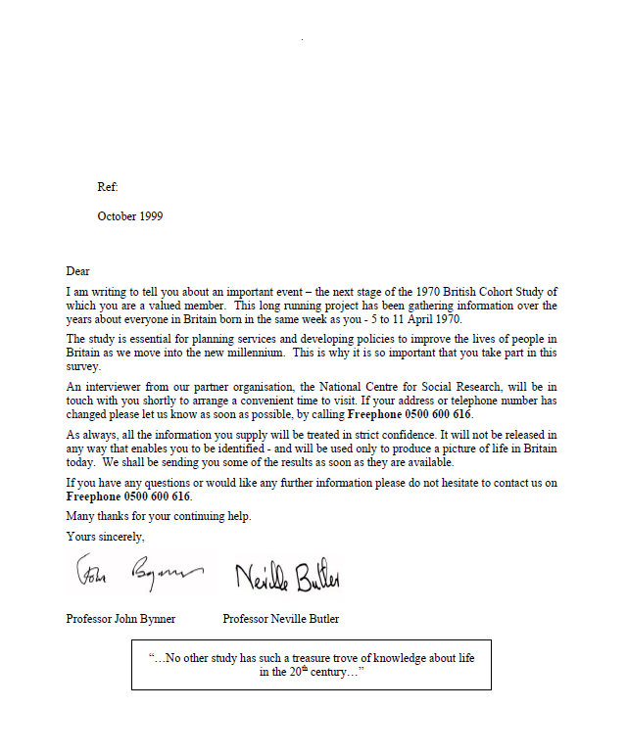
BCS70 2000 – Advance Letter

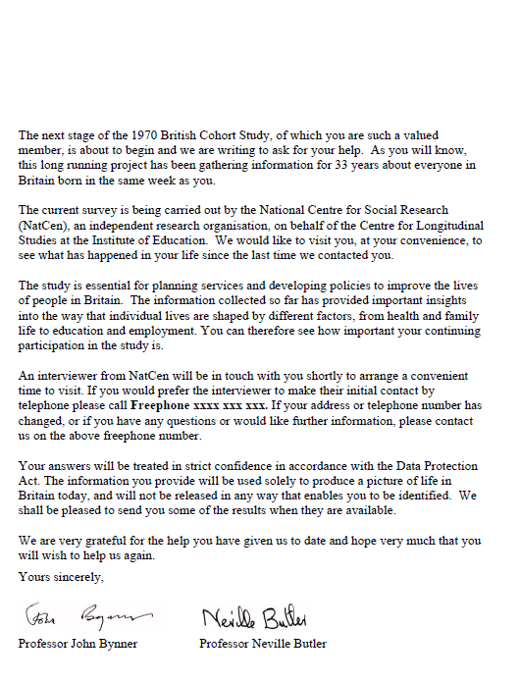
BCS70 2004 Advance Letter – Core sample

BCS70 2004 Advance letter – Parent and Child sample

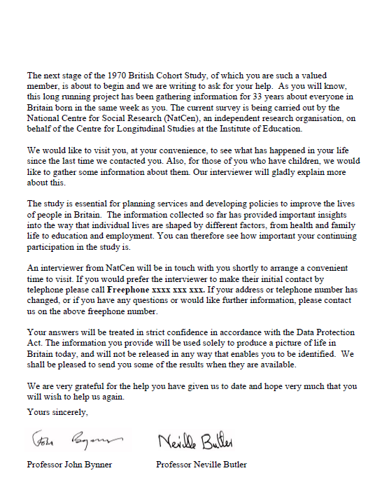
BCS70 2008 – Advance Letter

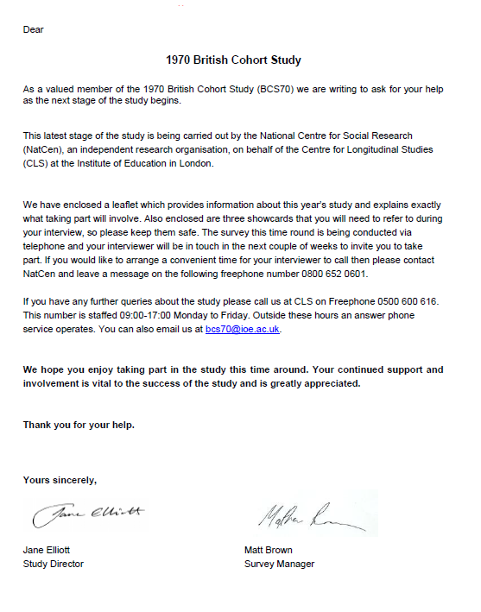
BCS70 2008 – Leaflet accompanying the Advance Letter
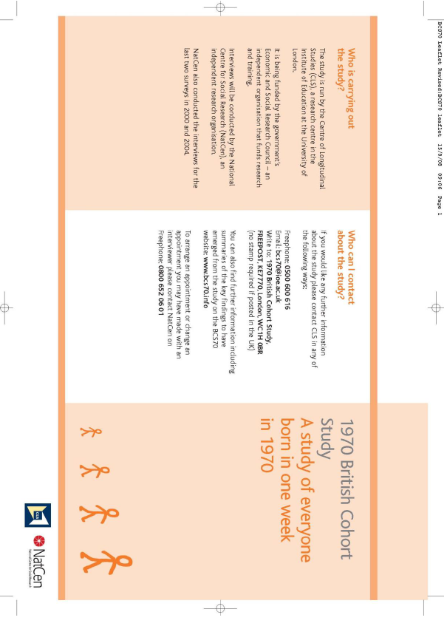

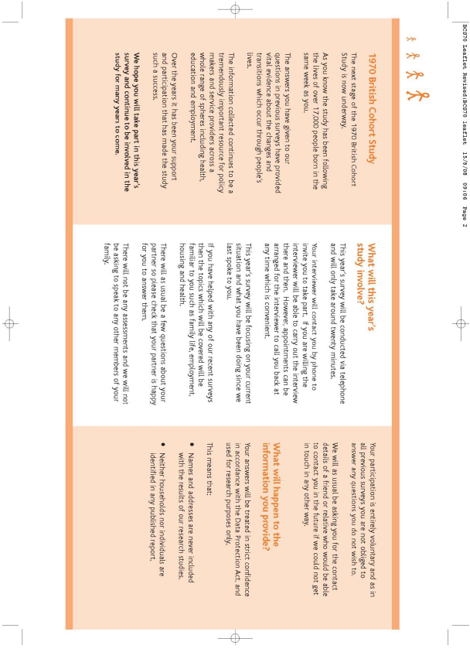

BCS70 2012

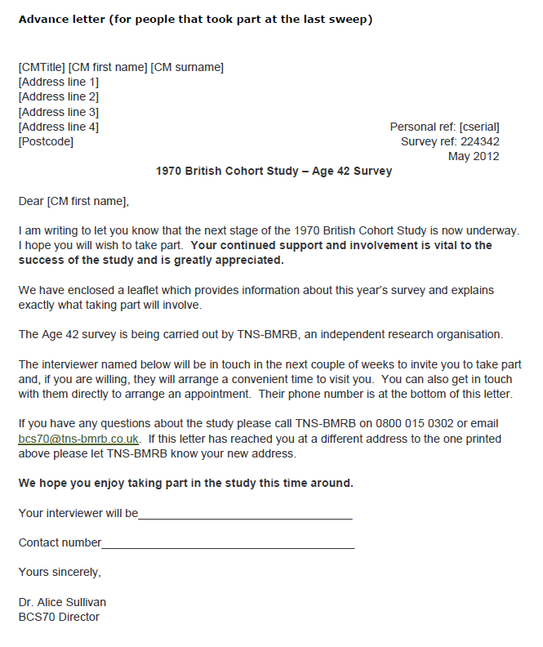
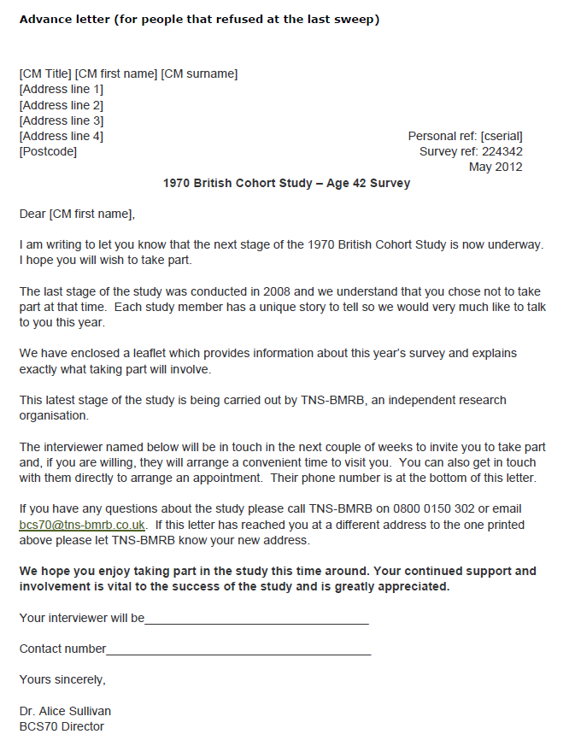
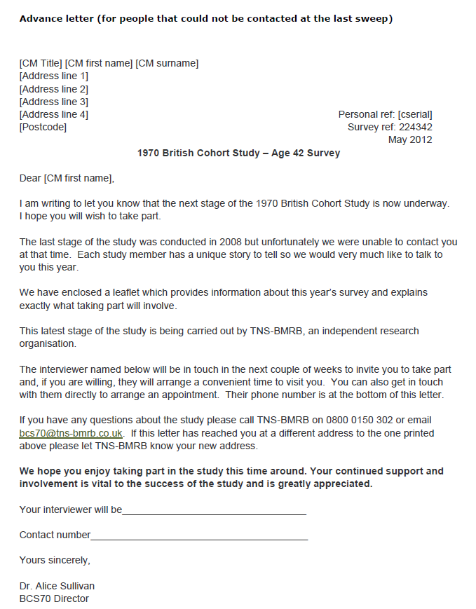
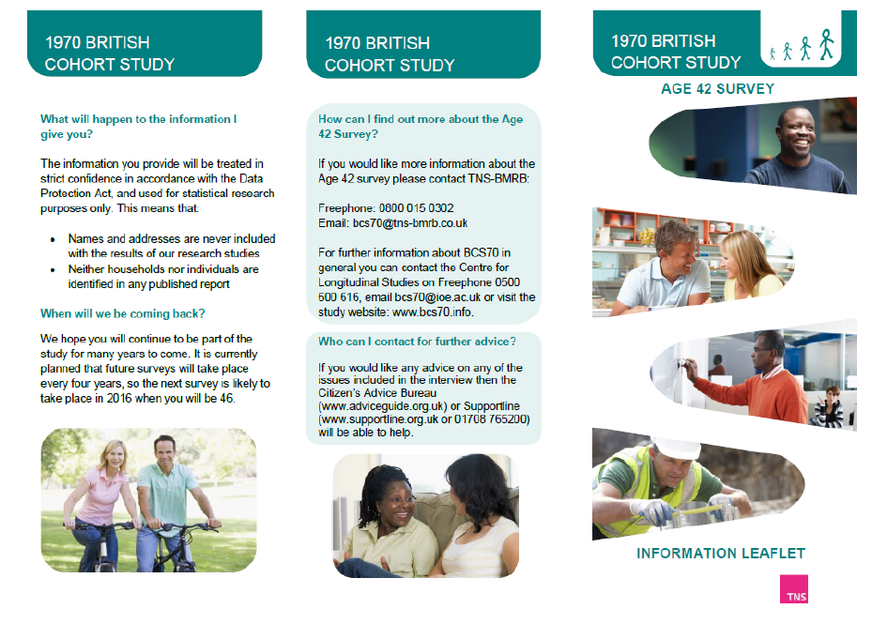
Leaflet accompanying the advance letter
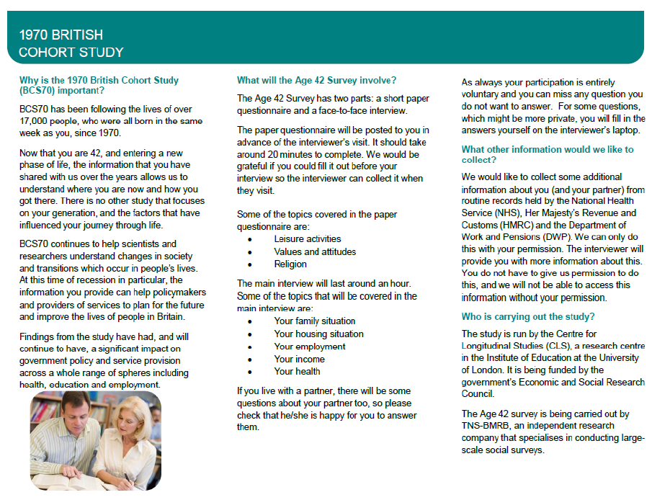
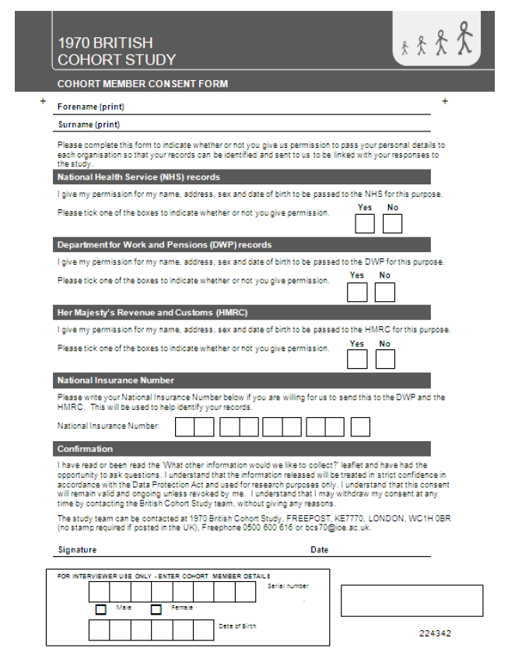
Consent form – Cohort Member data linkage

Consent form – Partner data linkage
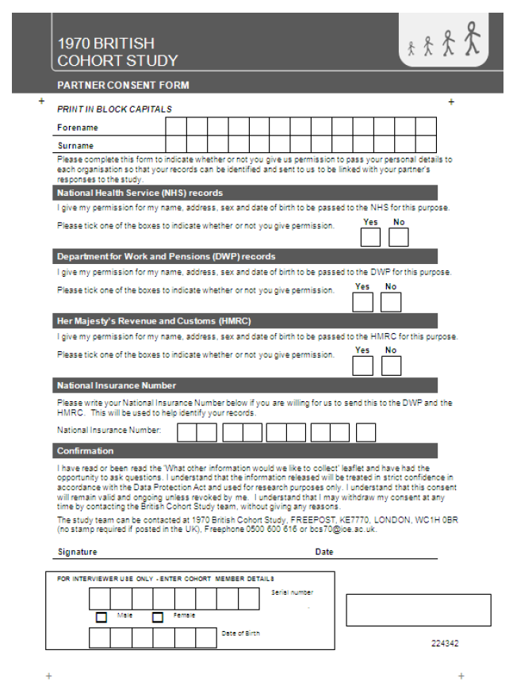
Data linkage leaflet
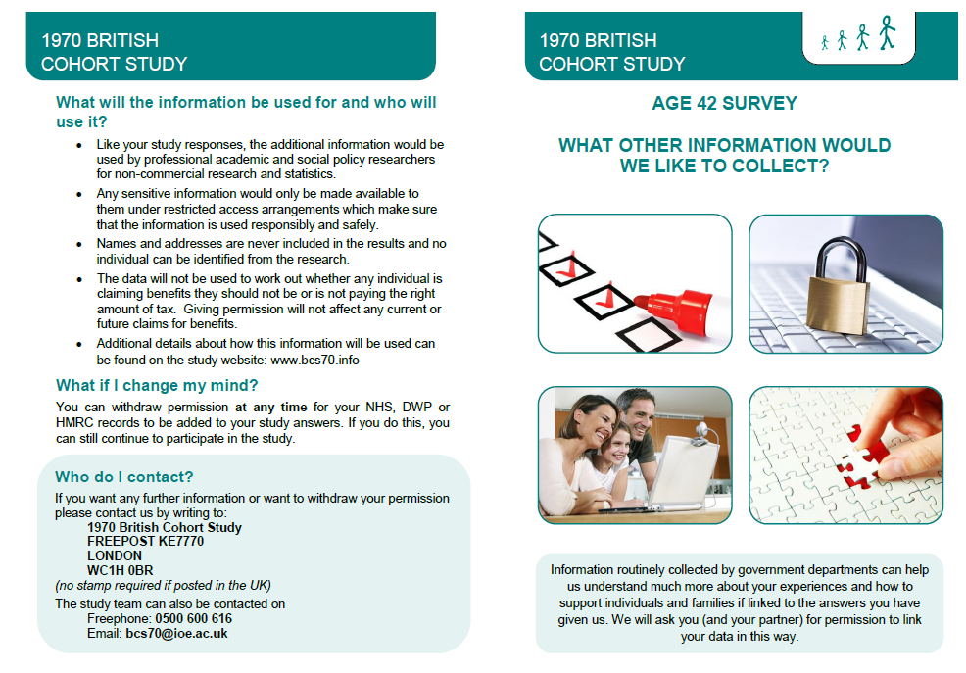
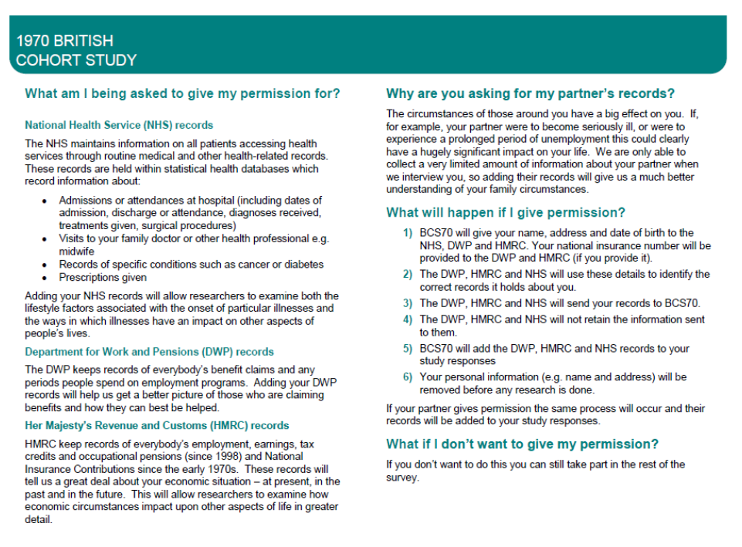
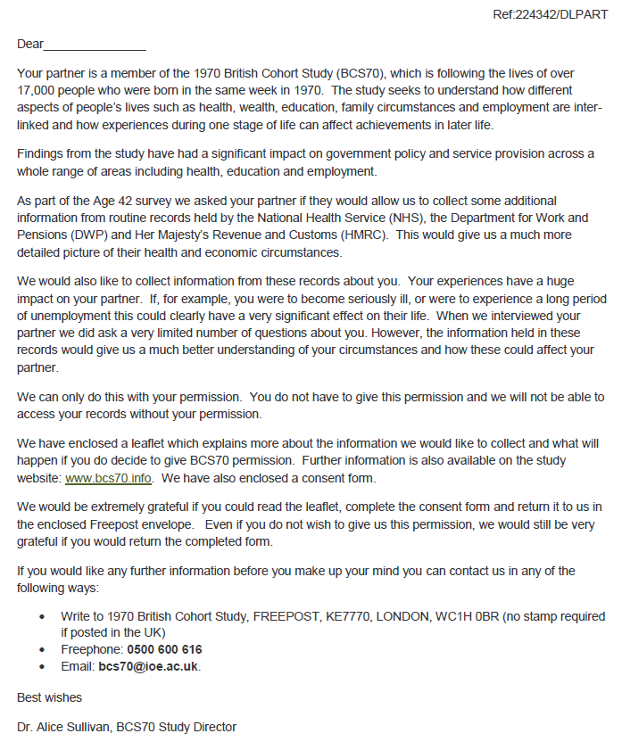
Data linkage letter - Partner

The National Survey of Health and Development (NSHD) and the National Child Development Study (NCDS), based on births in GB during one week in 1946 and 1958 respectively; and the Millennium Cohort Study (MCS), based on births in selected areas of the UK over one year beginning 2000.
GB (Great Britain) comprises England, Wales and Scotland. UK (United Kingdom comprises GB and Northern Ireland.
http://www.ukdataservice.ac.uk/
For more details see the NHS National Research Ethics Service website: http://www.nres.npsa.nhs.uk/

