Millennium Cohort Study – Ethical review and Consent

Introduction

1. This note reports on the approach adopted to ethical review and informed consent for the various stages of the Millennium Cohort Study (MCS) - a continuing, multi-disciplinary longitudinal study which takes as its subjects all those born in selected areas of England, Scotland, Wales and Northern Ireland over 12 months in 2001/2.

2. Below, a brief summary of the background to the study is followed by an account of how the approach to ethical review and consent has changed over the course of the study to date. Examples of letters, leaflets and consent forms used for various MCS surveys are provided in an Annex

Background

3. The Millennium Cohort Study (MCS) is a multi-disciplinary research project following the lives of around 19,000 children born in the UK in 2000-1. It is the most recent of Britain’s world-renowned national longitudinal birth cohort studies. The study has been tracking the Millennium children through their early childhood years and plans to follow them into adulthood. It collects information on the children’s siblings and parents. MCS’s field of enquiry covers such diverse topics as parenting; childcare; school choice; child behaviour and cognitive development; child and parental health; parents’ employment and education; income and poverty; housing, neighbourhood and residential mobility; and social capital and ethnicity.

4. The study was commissioned by the Economic and Social Research Council (ESRC - http://www.esrc.ac.uk/), whose funding has been supplemented by a consortium of Government departments and the Wellcome Trust (http://www.wellcome.ac.uk/)

5. The data for all MCS sweeps is available to researchers from the UK Data Service (http://www.ukdataservice.ac.uk/).

MCS and ethical review

6. Those responsible for the study have been concerned that appropriate procedures for ethical review and consent are followed. Currently in the UK, probably the most important route for ethical approval for studies like MCS is the National Health Service (NHS) Research Ethics Committee (REC) system. .

7. NHS Research Ethics Committees (RECs) are appointed by the Strategic Health Authorities in England, their equivalents in Scotland and Wales and the Health and Social Care Business Services Organisation in Northern Ireland. RECs safeguard the rights, safety, dignity and well-being of people participating in research. They review applications for research and give an opinion about the proposed participant involvement and whether the research is ethical. Each consists of between seven and 18 volunteer members. At least one-third of the members must be ‘lay’ whose main personal or professional interest is not in a research area. The remainder of the committee are expert members, who are specialists including doctors, other healthcare professionals and academics.

8. MREC ethical approval has been sought for all MCS follow-ups as indicated in the table below..

MCS Ethical approval 2000-2008

Survey | Age | Year | Approval
MCS1 | 9 months | 2000/1 | South West MREC | MREC/01/6/19
MCS2 | 3 years | 2003/4 | London MREC | MREC/03/2/022
MCS3 | 5 years | 2005/6 | London MREC Committee. | 05/MRE02/46
MCS4 | 7 years | 2007/8 | Yorkshire MREC | 07/MRE03/32
MCS5 | 11 years | 2011/12 | Yorkshire and The Humber – Leeds East | 11/YH/0203

9. Separate MREC approval has also been obtained for a number studies that gather additional information from and/or about the MCS cohort, including the collection of oral fluids, milk teeth and the monitoring of activity. Further information is available from the CLS website (http://www.cls.ioe.ac.uk/) or by emailing: clsfeedback@ioe.ac.uk

MCS and consent

10. The approach to consent has also been consistent. MRECs are most often concerned to see explicit written consent to all or particular elements of a survey and, from the outset MCS has sought informed parental consent. Letters and leaflets sent in advance of the surveys have summarised what participation in the survey will involve and written consent has been sought from parents for their participation and the participation of their child(ren). Written consent has also been sought for gathering information from health, education and economic records and from teachers.

11. Where parents give consent to the participation of their child(ren) in one or more elements of a survey the inclusion of the child(ren) requires their agreement and compliance. Although no attempt has been made to date to obtain the written consent of the MCS child subjects, it is anticipated that such consent will be sought in future surveys.

12. As with the other CLS cohort studies and irrespective of any consent or assent, individuals are able to refuse to participate in any element of a survey or withdraw from the study at any time by simply expressing the wish to do so.

13. A summary of the consents sought for each MCS survey is provided below. Copies of the relevant letters, leaflets and consent forms are provided in the Annex.

MCS1 Consents

14. The sample for the first MCS survey (MCS1) was drawn from all live births in the UK over 12 months from 1 September 2000 in England & Wales and 1 December 2000 in Scotland and Northern Ireland. It was selected from a random sample of electoral wards, disproportionately stratified to ensure adequate representation of all four UK countries, deprived areas and areas with high concentrations of Black and Asian families. Children with appropriate birth dates and living in selected wards were selected from the Child Benefit register by the Department of Social Security (DSS) responsible for administering the benefit. DSS sent a letter and leaflet to selected families giving them an opportunity to opt-out of the survey. The uirst visit

15. At the end of the main interview, the respondent who was the natural mother (or, in her absence, the main carer) was asked to read and decide whether to sign a consent form giving permission to link their survey data to health data. Interviewers were asked to ensure that all respondents read this form thoroughly before deciding whether or not to sign. If a respondent was unable to read the form for any reason (perhaps due to reading/sight problems or because they are attending to the baby’s needs), interviewers were instructed to read it out.

16. There were two distinct consents on the form:
- The first (A) asked for consent to the research team obtaining information about the respondent’s pregnancy and baby’s birth from health records (computerised summaries, not individual notes). Only information about pregnancy and birth was to be obtained. This information will be of great benefit to the study as it will give researchers a more complete picture of cohort member’ starts in life.

- The second (B) consent asked to link to the National Health Service Central Register (NHSCR). This study, like the previous cohort studies, would like to mark the records of the cohort children on this register. This is to help keep track of them in the future, should other contact be lost. The register contains NHS number and the health authority for which their GP works, but not detailed medical records or individual addresses. Though neither the NHSCR nor the Health Authority provide addresses directly, other cohort studies have been able to re-establish lost contact with some cohort members by asking the health authority to forward a letter. It is, of course, up to the cohort member or their family to decide whether or not to respond.

The NHSCR can also tell the study team if a cohort member dies though interviewers were not required to volunteer this information unless asked.

17. Respondents who were willing to give consent signed and printed their name and dated the form. It was possible to give one consent but withhold the other simply by crossing out either A or B. Only the natural mother can give consent for her pregnancy records to be accessed. If a father or other relative was the main carer and was completing this consent form, they could give consent with respect only to clause B

18. The consent form was translated into the same languages as the advance letter and simplified leaflet.

19. As the table below shows, consent to linkage was given for 9 out 10 children in the MCS1 achieved sample.

Consent to linkage to birth and hospital records

 | Babies | Consents | Percent
Birth registration | 18,818 | 17,019 | 90.4
Hospital records | 18,818 | 16,889 | 89.8

20. Examples of letters, leaflets and consent forms used for MCS surveys are reproduced in the Annex below

MCS2 Consents

21. At the start of the MCS data collection, the interviewer asked the main respondent for written consent to the process by completing a Consent Form consisting of three separate sections relating to:
- The parental interview
- The Cohort Child - covering the assessments, measurements, collection of oral fluids and gathering of administrative data on hospital admissions
- Older siblings - including permission for CLS to collect statistical data from the relevant authorities from school records. It was made clear to respondents that they could give permission to some elements and refuse permission for others and the Consent Form made provision for this.

22. The rates of consent in these different areas are shown below.

MCS2 Consents

 | Eligible | Number | Percent
Main interview and self-completion:
a) Interview | 15586 | 15446 | 99.1
b) Self-completion | 15414 | 14846 | 96.3
Consent for the cohort child:
Assessments:
a) Bracken Basic Concepts Scale - knowledge of colours,  letters, numbers and counting, sizes, comparisons and  shapes | 15808 | 14969 | 94.7
b) British Ability Scales - Naming Vocabulary | 15808 | 15167 | 95.9
Measurements:
c) Standing height | 15808 | 14638 | 92.6
d) Body weight | 15808 | 14814 | 93.7
Sample of saliva | 12471 | 11034 | 88.5
Information from NHS records on date and reason for hospital admission and treatment of cohort member from birth to age 7 years | 15809 | 13022 | 82.4
Consent for older siblings
Part A: School records  Information from school records on cohort member’s siblings’ school performance | 11868 | 10296 | 86.8
Part B: Older siblings self-completion questionnaire for children aged 10-15 years | 2170 | 2092 | 96.4

23. Examples of letters, leaflets and consent forms used for MCS surveys are reproduced in the Annex below

MCS3 Consents

24. As with all MCS surveys, an important requirement for the MCS3 survey was that all adult respondents had to give informed consent in writing to take part in the study. Written consent was also required from a parent or guardian for the participation of a child. This necessitated the use of several consent forms that had to be completed before parts of the survey could be administered. In addition, written consent was requested for linkage to health records, school records and to approach the class teacher.

25. Interviewers were prompted to collect the data collection consents at the end of the household questionnaire. It was possible for interviewers to leave the collection of some of the data collection consents until later in the interview, and prompts were built into several places within the CAPI questionnaire. Interviewers were prompted to collect consent for linkage to health records, school records and to approach the class teacher towards the end of main interview.

26. In total there were five consent forms for families in England, and four for families in other countries:.

- Consents 1 and 2: Data collection - The purpose of these forms was to gain consent from the parent(s) to administer the survey, and also to gain permission to carry out the cognitive assessments and physical measurements of the cohort children.

Consent 1 was usually completed by the main carer of the cohort child, who was also usually the main respondent, but it was possible for it to be completed by either parent. It was split into two parts.

- The first part of the form gained consent to administer the CAPI and CASI for the parent or carer, and it was necessary for this to be completed before the interviewer started to administer the CAPI to the relevant parent.

- The second part of the form was to gain consent to administer the child cognitive assessments and measurements. Interviewers were first prompted to ask for this consent at the end of the household questionnaire. If they did not gain consent at this stage, they were prompted again at the end of the main questionnaire.

- Consent 2 was designed to collect consent to administer the CAPI and CASI to the other parent or carer, and was usually used for the partner respondent.

- Consent 3: Cohort child health records - The main respondent CAPI contained questions about the cohort child’s health. To supplement this information permission was asked for access to the cohort children’s hospital admissions and treatment from the routine records kept by the National Health Service.

This consent had been included in MCS2, where permission, if given, covered data up to and including when the cohort children were seven years of age.

Interviewers were prompted to collect this consent towards the end of the main interview. If permission was given at MCS2, then permission was not needed again at MCS3.

- Consent 4: Cohort child school records - (England only) - For every pupil in England, teachers complete the Foundation Stage Profile at the end of the child’s reception year. The Foundation Stage profile collects information about children’s social and personal, communication, language, literacy and mathematical development.

The information is passed from schools to the Local Education Authority where it is held centrally.

The fourth consent form in England asked for permission to access the child’s Foundation Stage Profile. Interviewers were prompted to collect this consent towards the end of the main interview.

- Consent 4: Cohort child teacher survey - (Northern Ireland, Scotland and Wales) - At present, only teachers in England complete the Foundation Stage Profile described above. In order to collect similar information in Northern Ireland, Scotland and Wales, it was necessary to approach teachers directly and ask them to complete a questionnaire. Consent 4 collected consent to do this for each child.

This formed the Teacher Survey, and details of this are contained in a separate technical report. Interviewers were prompted to collect this consent towards the end of the main interview.

- Consent 5: Older siblings questionnaire placement - England only - The final consent form for England was to gain consent to place the older siblings questionnaires where applicable.

Almost two thirds (63.4%) of households had given permission for their cohort child’s health records to be accessed at MCS2. The majority of parents who did not give permission for this at MCS2 did give permission at MCS3.

27. The rates of consent in these different areas are shown below.

MCS3 Consents

 | Target | Number | Percent
Parent1 interview and self-completion
a) Answering questions put to me by the interviewer | 15246 | 15185 | 99.6
b) Completing a questionnaire
Age 5 Child: Assessments and Measurements^{b}
a) Story of Sally & Anne | 15549 | 15196 | 98.3
b) Picture similarities
c) Naming vocabulary
d) Pattern construction
e) Height | 15549 | 15236 | 98.6
f) Weight
g) Waist circumference against skin OR
h) Waist circumference over clothing
Parent 2 interview and self-completion
a) Answering questions put to me by the interviewer | 12219 | 10778 | 80.1
b) Completing a questionnaire
Parental consent to release child information from NHS records | 15459 | 14905 | 96.4
Parental consent to release child information from school records | 9884 | 9210 | 94.2
Teacher Survey (Northern Ireland, Scotland and Wales only) | 5495 | 3332 | 60.6
Parental consent to place older sibling questionnaire | 2633 | 2493 | 94.7

28. Examples of letters, leaflets and consent forms used for MCS surveys are reproduced in the Annex below

MCS4 Consents

29. There are 5 consent forms associated with MCS4:

- Consent 1: Main respondent - The purpose of this form was to gain consent to administer the survey, and also to gain permission to access information from other sources for the main respondent.

The consent form was split into two parts:

Part A was used to gain consent to administer the CAPI and CASI for the main respondent, and it was necessary for this part of the form to be completed before the interviewer started to administer the CAPI to the main respondent.

Part B was used to gain permission to release the main respondent’s routine health and economic records; this part was completed at the end of the main respondent interview.

- Consent 2: Cohort child data collection - This form was used to gain consent from either the main respondent or partner for the administration of the cohort child data-collection elements: cognitive assessments and physical measurements, physical activity monitoring and child self completion questionnaire. All sections of this consent form had to be completed by the same parent or guardian.

There were several opportunities to complete this consent form. Consents for the assessments and measurements were asked immediately after the household grid and again at the end of the main questionnaire (if not collected after the household grid). CAPI also asked interviewers to confirm that written consent had been obtained prior to administering each of the child elements.

For the child self-completion questionnaire, interviewers were asked to collect consent immediately after the household grid or at the end of the main questionnaire. For the activity monitor interviewers were prompted to explain it and collect consent after the physical measurements were taken.

- Consent 3: Cohort child - information from other sources - In the main respondent questionnaire there were many questions about the cohort child’s experiences at school and their health and education. To supplement this information, permission was asked to send a questionnaire to the cohort child’s school teacher, and to access information held in routine records on education and health:

Part A of this consent form sought consent to administer the teacher questionnaire. Details of the Teacher Survey are contained in a separate technical report.

Part B of this consent form asked for parental consent to access information held in routine records on education and health.

Interviewers were prompted to collect this consent at the end of the main respondent interview, although the form could be signed by either the main respondent or the partner.

- Consent 4: Siblings - health and education records - This form was used to gain permission from either the main respondent or partner to access the routine heath and education records of the cohort child’s siblings in order to gain further insights into the cohort child’s development in relation to their siblings.

All types of siblings were eligible to be selected (natural, step, foster, adoptive, half) and up to four children were selected by the CAPI, and their names and other details will be shown on the consent screen. If there were more than four siblings, the four youngest were be selected.

Interviewers were prompted to collect this consent at the end of the main respondent interview, although the form could be signed by either the main respondent or the partner.

- Consent 5: Partner respondent - The purpose of this form was to gain consent from the partner to administer the survey, and also to gain permission to access information from other sources.

Part A of this form was used to obtain consent from the partner respondent to administer the survey (CAPI and CASI), and interviewers were prompted to collect this consent before administering the CAPI to the partner.

Part B was used to gain permission to release the partner’s routine health and economic records; this part was completed at the end of the partner interview.

The consent forms were carbon-backed and printed in triplicate. One copy was retained by the respondent, and the other two copies returned by interviewers to NatCen’s operations department.

30. The rates of consent in these different areas are shown below.

MCS4 Consents

 | Target | Number | Percent
Part A: Interview and self-completion
a) Answering questions put to me by the interviewer | 13857 | 13797 | 99.6
b) Completing a questionnaire
Part B: Health and economic records
Permission to release information from routine health records | 13797 | 11977 | 86.8
Permission to release information from routine economic records | 13797 | 11063 | 80.2
Age 7 Child: Assessments and Measurements | 14043 | 13835 | 98.5
a) Story of Sally & Anne
b) Word Reading
c) Progress in Maths
d) Pattern Construction
e) Height | 14043 | 13873 | 98.8
f) Weight
g) Waist circumference against skin OR
i) Body fat percentage
h) Waist circumference over clothing
Age 7 Child: Physical activity and monitoring
Consent to wear an activity monitor to have their physical activity measured | 14043 | 12854 | 91.5
Age 7 Child: Self-completion questionnaire | 14043 | 13244 | 94.3
Part A: Teacher survey | 14043 | 12655 | 90.1
Part B: Health and education records
information from health records | 14043 | 13047 | 92.9
information from education records | 14043 | 13170 | 93.8
Health and education records – SIBLINGS (For up to 4 children)
information from health records | 17356 | 15487 | 89.2
information from education records | 17356 | 15482 | 89.2
Part A: Interview and self-completion
a) Answering questions put to me by the interviewer | 10940 | 9180 | 83.9
b) Completing a questionnaire
Part B: Health and economic records
Permission to release information from routine health records | 9429 | 7908 | 83.9
Permission to release information from routine economic records | 9429 | 7290 | 77.3

31. Examples of letters, leaflets and consent forms used for MCS surveys are reproduced in the Annex below

MCS5 Consents

32. All adult respondents had to give informed consent in writing to take part in the study. Written consent was also required from a parent or guardian for the participation of a child. It is worth noting that parents were not asked to consent on behalf of the child, but were asked for their permission to allow the interviewer to speak to the child and ask for their consent to participate in each element.

33. Interviewers were also required to gain consent from the child that was as fully informed as possible. In order to ensure this, children needed to understand the full details of processes/ experience of participation (e.g. the burden/emotional impact) and as much as could possibly be expected about the reasons for the study and how their data will be held and used.

34. There were four data collection consent forms and, for each, there was a related leaflet (or leaflets) for the respondent to read (or for the interviewer to explain). The table below summarises the consent forms and the corresponding leaflets

Consent form | Study elements covered | Purpose | Relevant respondent communication materials
Main parent/guardian | CAPI and CASI and data linkage | To gain consent to administer the survey; and also to gain permission to link to the respondents economic records (data linkage).  The consent form was split into two parts.  The first part was used to gain consent to administer the CAPI and CASI for the main respondent, and it was necessary for this part of the form to be completed before the interviewer started to administer the CAPI to the main respondent.  The second part was used to gain permission to release the main respondent’s economic records; this part was typically completed at the end of the main respondent interview. | Advance leaflet for parents (“What is the Child of the New Century age 11survey?”) and data linkage leaflet (“Is there any other information we would like?”)
Child elements (completed by either the main parent OR the partner) | All child data collection elements:  - cognitive Assessments and physical Measurements  - child self-completion questionnaire  - permission to contact the child’s teacher (England & Wales only) | This form was used to gain consent from either the main respondent or partner to ask the child whether they would be willing to complete the cohort child data-collection elements: cognitive assessments, physical measurements and child self completion questionnaire. In England and Wales only, the consent form also asked the main respondent or partner if they would provide consent to ask the child if they would be willing for their class teacher to be contacted. All sections of this consent form had to be completed by the same parent or guardian.  There were several opportunities to complete this consent form. Consent could be asked immediately after the household grid and/or at the end of the main questionnaire (if not collected after the household grid). CAPI also asked interviewers to confirm that written consent had been obtained prior to administering each of the child elements. | Child elements leaflet (“More information about the visit”) and for Teacher Survey consent (in England and Wales only): Advance leaflet for parents (“What is the Child of the New Century age 11 survey?”)
Consent from child | All child data collection elements:  - cognitive Assessments and physical Measurements  - child self-completion questionnaire  permission to contact the child’s teacher (England & Wales only) | This form was used to gain overall consent from the child for their participation in the study as a whole and to all individual child elements.  The consent form was split into two parts, the first part was used to communicate all key points to ensure fully informed consent to participation in the study as a whole was achieved, as far as the child was able, specifically:  - What the survey is for and what it involves as a whole;  - What participation is voluntary, that they don’t have to answer any questions they don’t want to, and that they can stop the interview at any time;  - That participation is voluntary, that they don’t have to answer any questions they don’t want to, and that they can stop the interview at any time;  - That the data will be kept confidentially.  The second part gained was used to consent to the cohort child data-collection elements: cognitive assessments, physical measurements and child self completion questionnaire. In England and Wales only, the consent form also asked the child if they would be willing for their | Advance leaflet for child (“How can I help with Child of the New Century?”)
Partner | Partner CAPI and CASI and data linkage | The purpose of this form was to gain consent from the partner to administer the survey, and also to gain permission to link to their economic records (data linkage).  The consent form was split into two parts. The first part was used to gain consent to administer the CAPI and CASI for the partner, and it was necessary for this part of the form to be completed before the interviewer started to administer the CAPI to the partner. The second part was used to gain permission to release the partner’s economic records; this part was completed at the end of the partner interview. | Advance leaflet for parents (“What is the Child of the New Century age 11 survey?”) and data linkage leaflet (“Is there any other information we would like?”)  (Plus potentially, partner letter)

35. The rates of consent in these different areas are shown below.

Consent form | Purpose | Target | Number | Percent
Main parent/guardian | - Consent to administer the survey  - Permission to link to the respondents economic records (data linkage) | - n  - n | - n  - n | - %  - %
Child elements (completed by either the main parent OR the partner) | Consent to:  - cognitive Assessments  - physical Measurements  - child self-completion questionnaire  - permission to contact the child’s teacher (England & Wales only) | - n  - n  - n  - n | - n  - n  - n  - n | - %  - %  - %  - %
Consent from child | Consent to:  - cognitive Assessments  - physical Measurements  - child self-completion questionnaire  - permission to contact the child’s teacher (England & Wales only) | - n  - n  - n  - n | - n  - n  - n  - n | - %  - %  - %  - %
Partner | - Consent to administer the survey  - Permission to link to the respondents economic records (data linkage). | - n  - n | - n  - n | - %  - %

31. Examples of letters, leaflets and consent forms used for MCS surveys are reproduced in the Annex below

Further information

n. Further information is available from the CLS website (http://www.cls.ioe.ac.uk/) or by emailing: clsfeedback@ioe.ac.uk. This document will be updated as new MCS datasets are available.

Annex: Examples of letters, leaflets and consent forms

Examples of letters, leaflets and consent forms used for various MCS surveys are reproduced below as follows

Page
- MCS1 Letters and Leaflets
- MCS1 Consent Forms
- MCS2 Letters and Leaflets
- MCS2 Consent Forms
- MCS3 Letters and Leaflets
- MCS3 Consent Forms
- MCS4 Letters and Leaflets
- MCS4 Consent Forms
- MCS5 Letters and Leaflets
- MCS5 Consent Forms

NB: The documents shown below are those used for families living in England and able to read English. There were often slightly different versions used in one or more of the other UK countries; and translations into Welsh and other languages were also available.

MCS1
See: MCS1 Technical Report on Fieldwork- http://www.cls.ioe.ac.uk/shared/get-file.ashx?id=782&itemtype=document

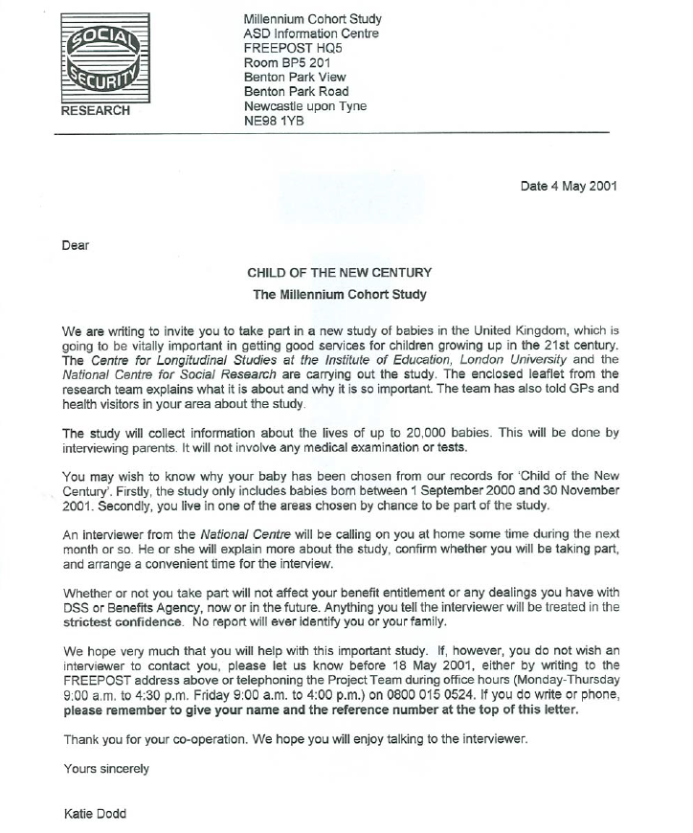
DSS Opt-out letter: English

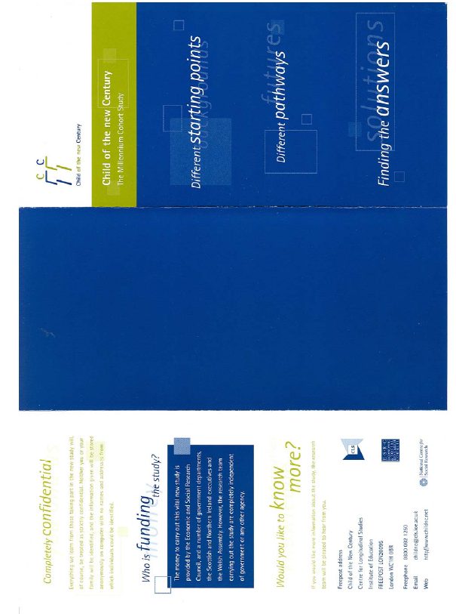
Study leaflet: English
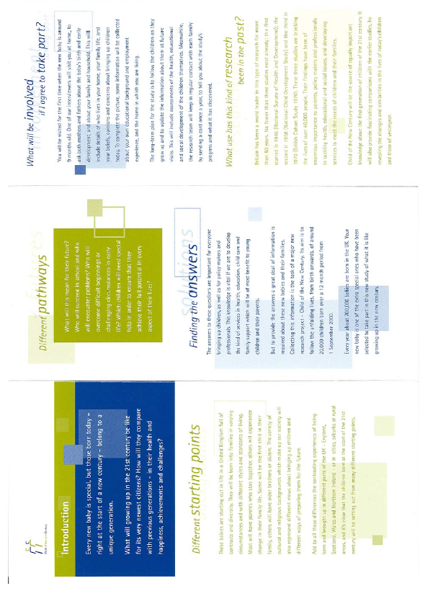
Advance letter
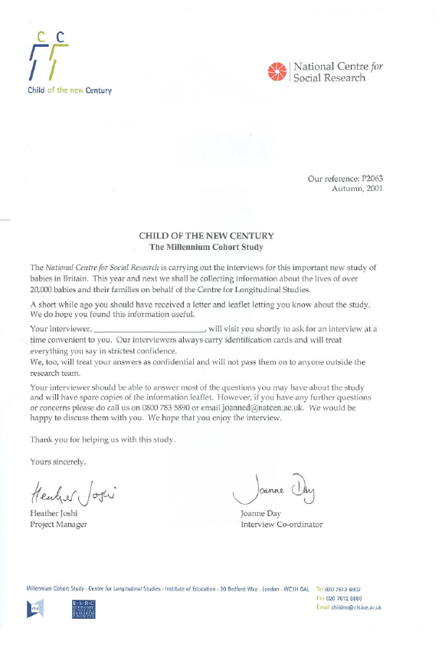
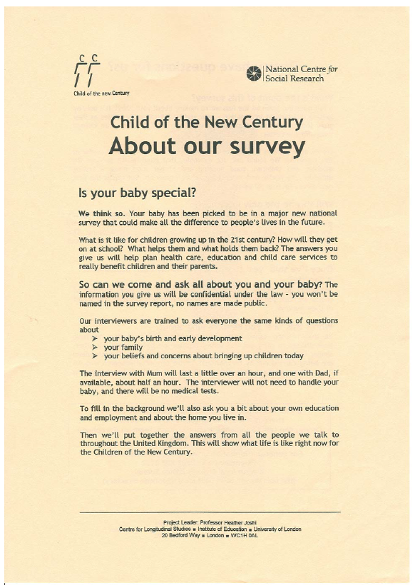
Information Sheet
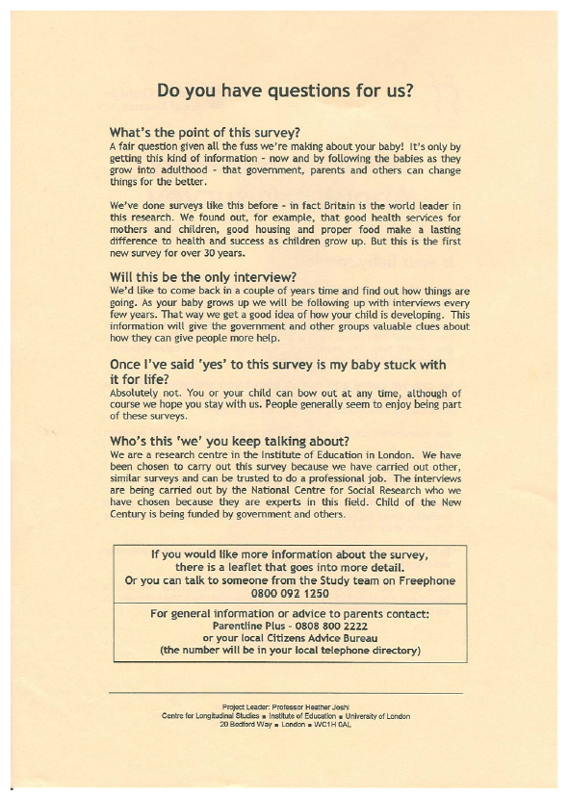
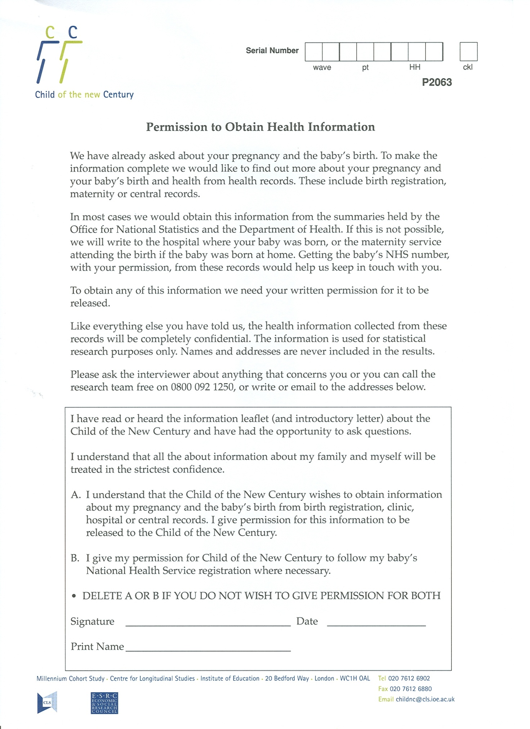
Consent Forms
MCS2
See MCS2 Technical Report on Fieldwork - http://www.cls.ioe.ac.uk/shared/get-file.ashx?id=328&itemtype=document and http://www.cls.ioe.ac.uk/shared/get-file.ashx?id=329&itemtype=document

Advance information sheet
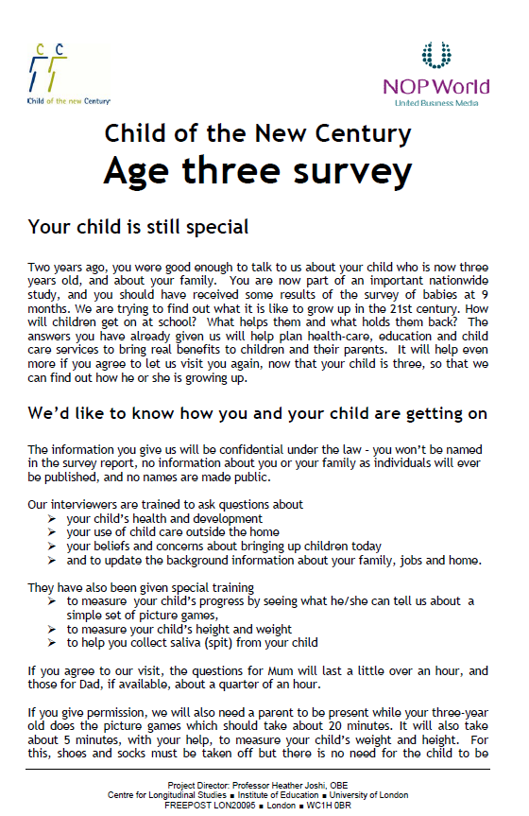
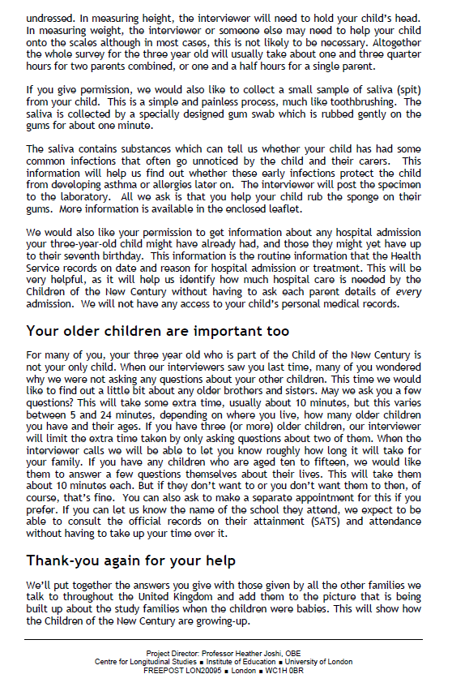
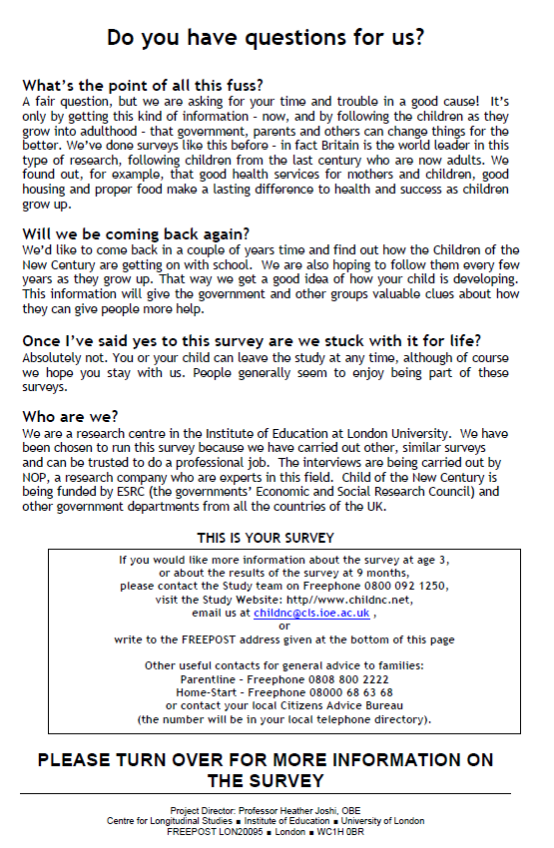
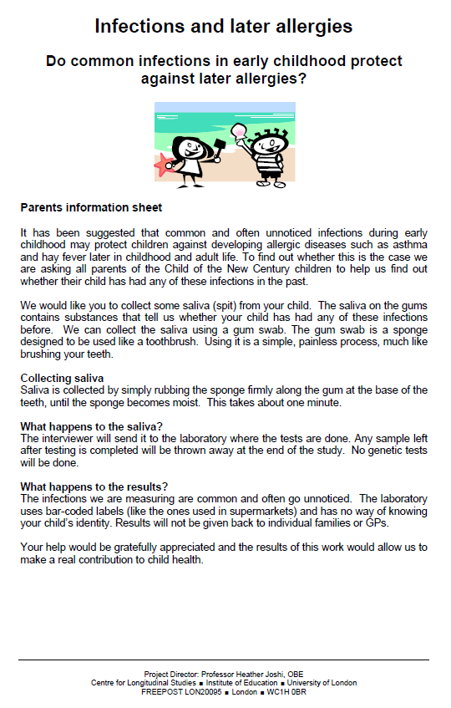
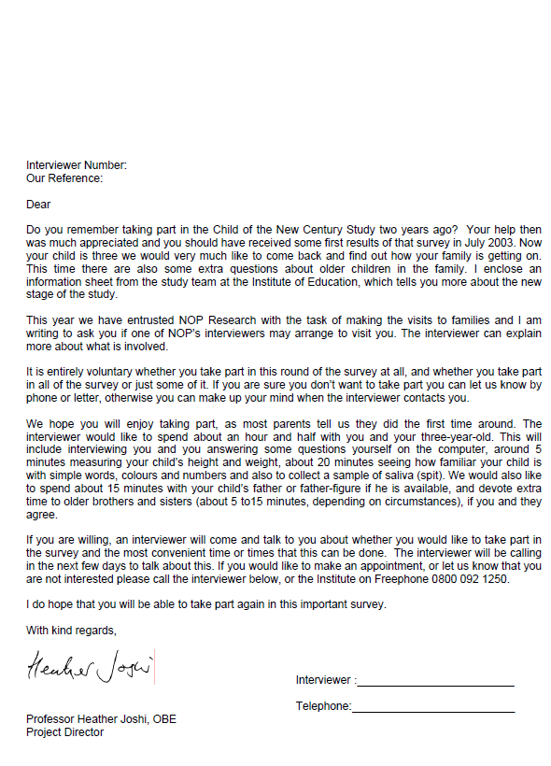
Advance letters
Consent forms

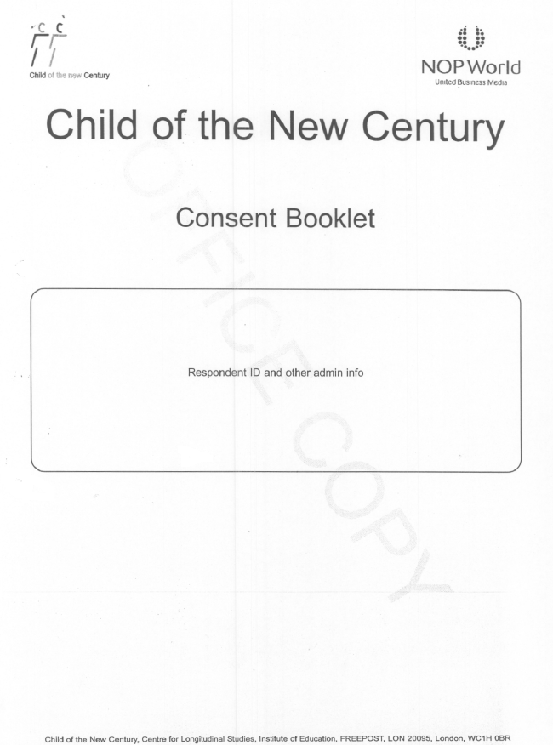

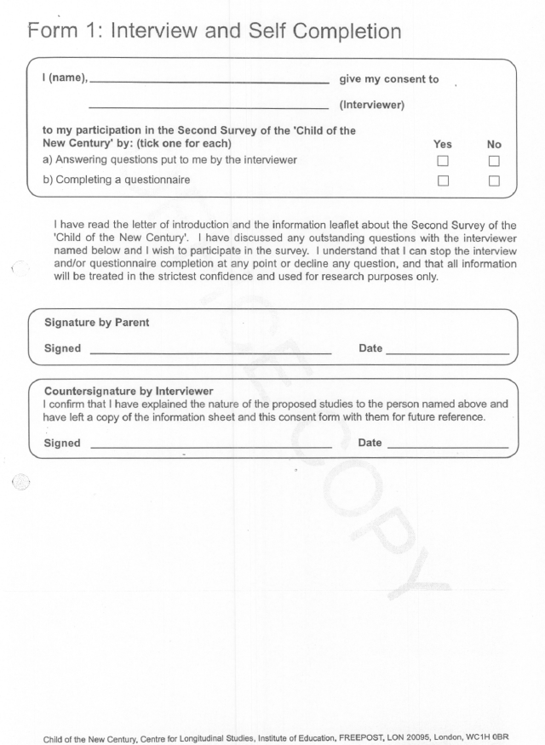
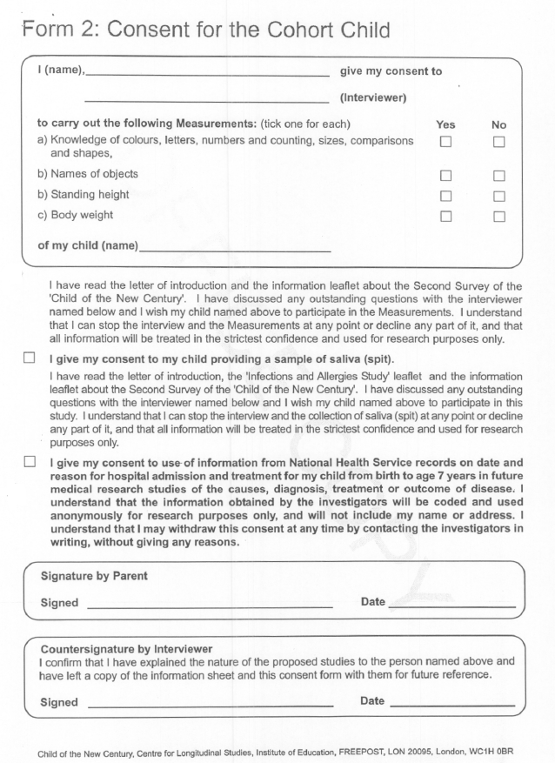
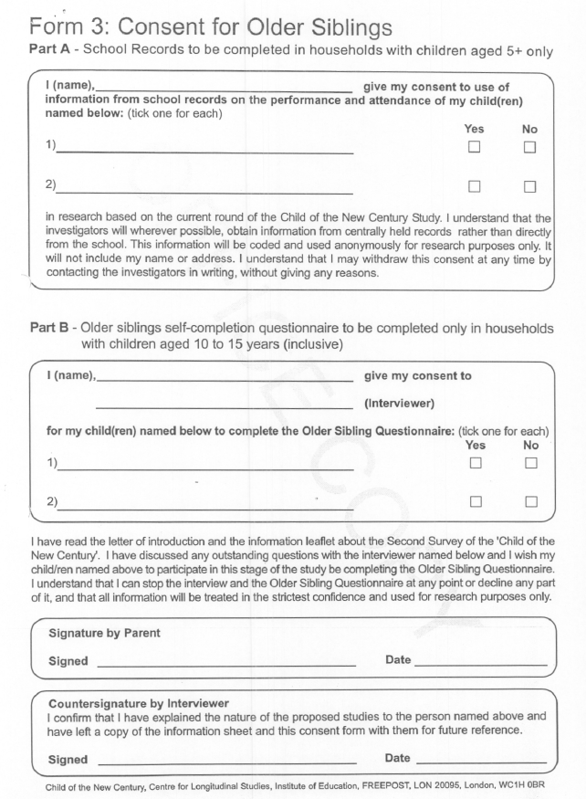
MCS3
See MCS3 Technical Report on Fieldwork - http://www.cls.ioe.ac.uk/shared/get-file.ashx?id=579&itemtype=document and http://www.cls.ioe.ac.uk/shared/get-file.ashx?id=618&itemtype=document

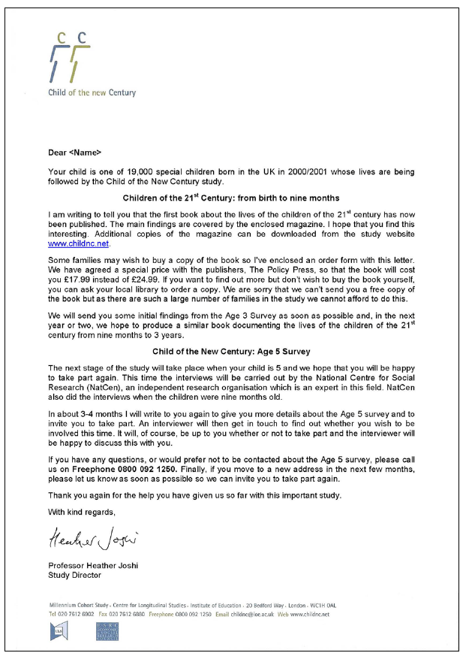
Pre-notification letter: England, Wales and Scotland
Advance letter: England and Scotland
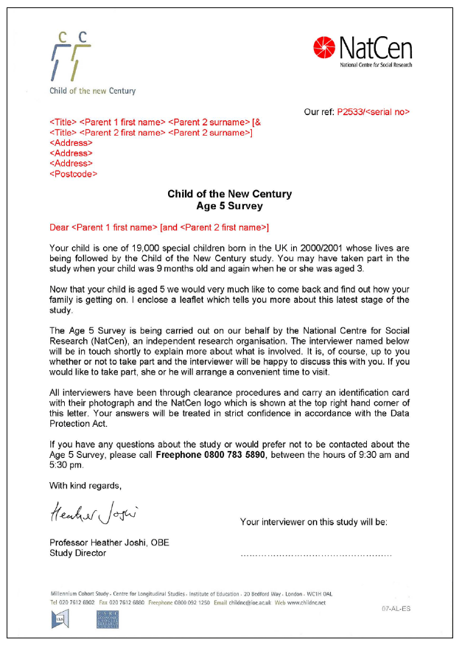
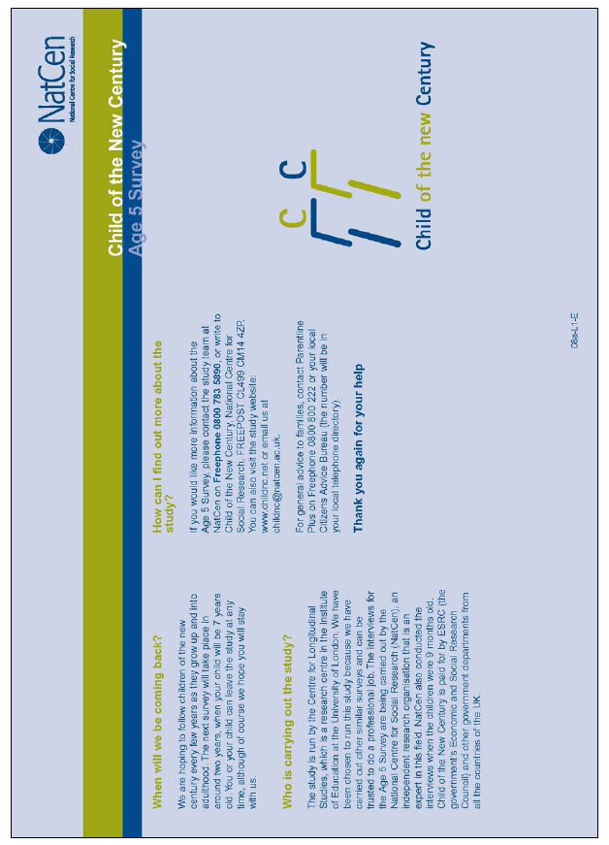
Leaflet sent with advance letter: England
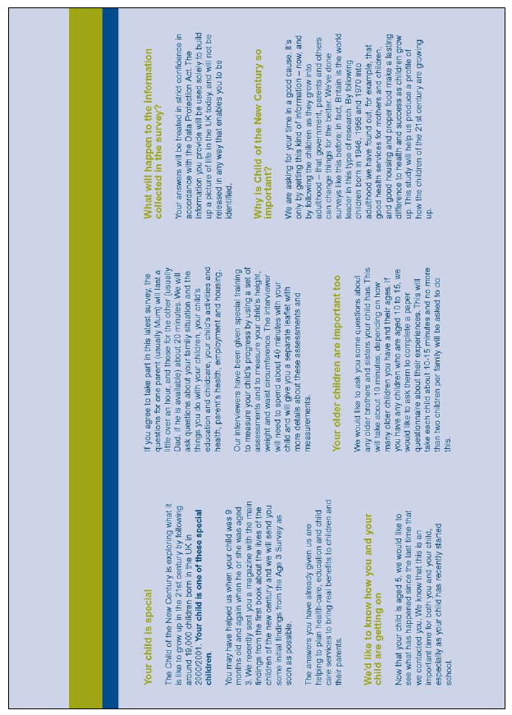
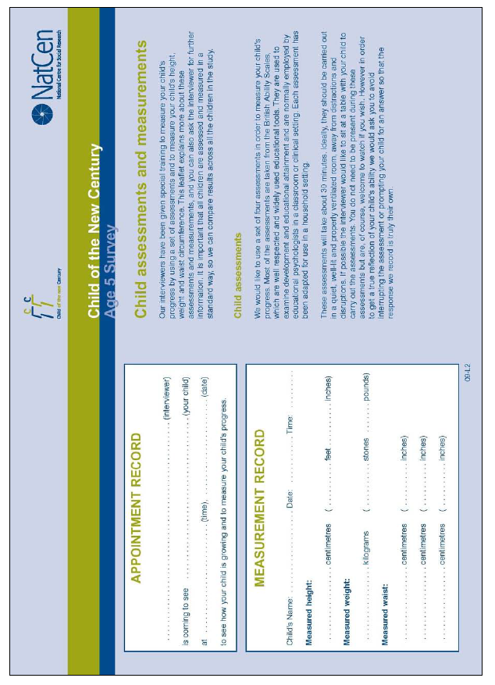
Second leaflet: England, Scotland and Wales
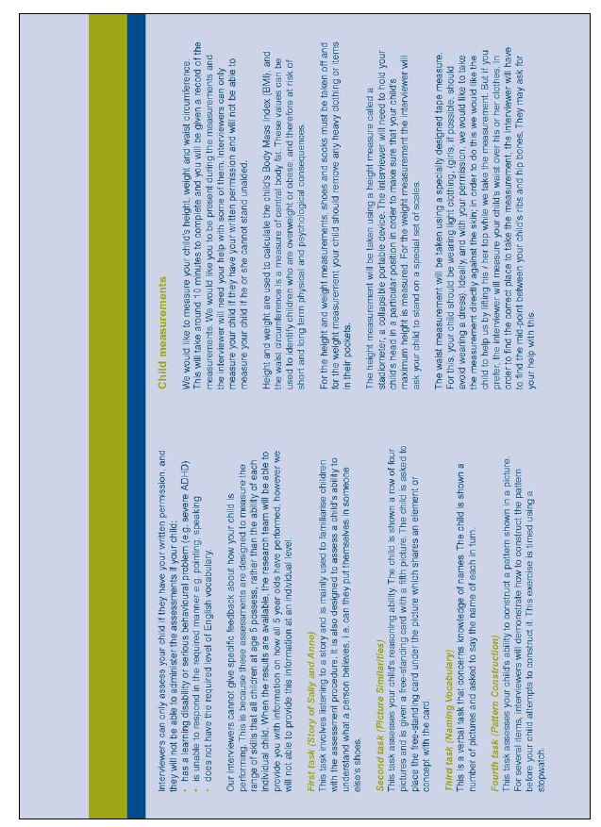
Consent forms: England
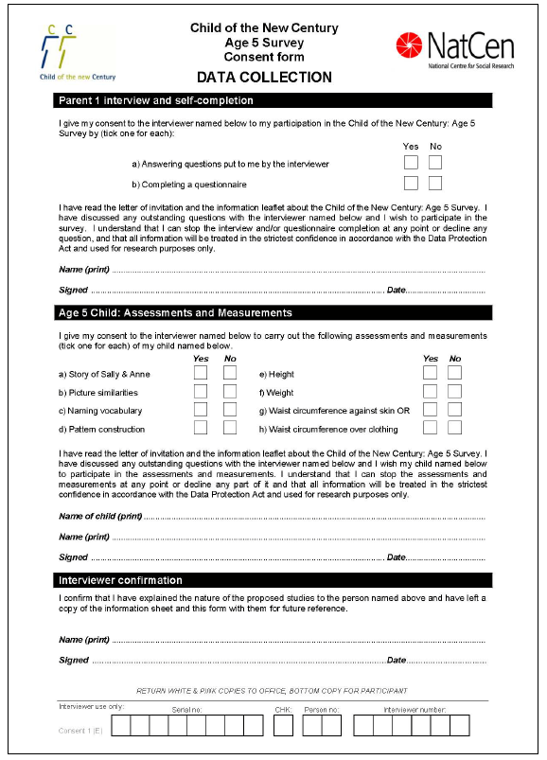
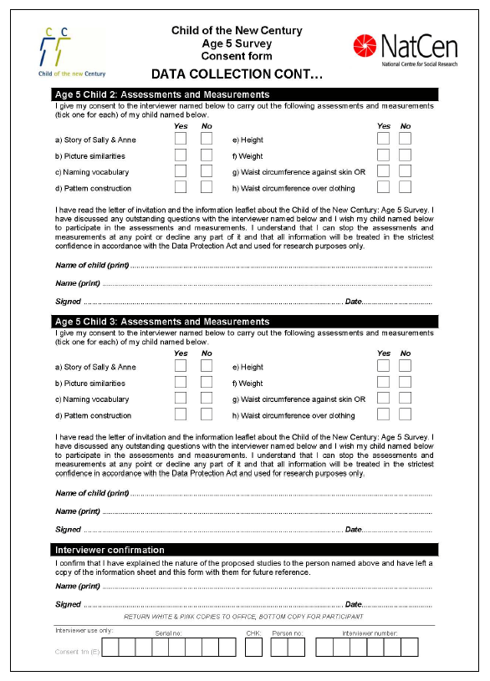
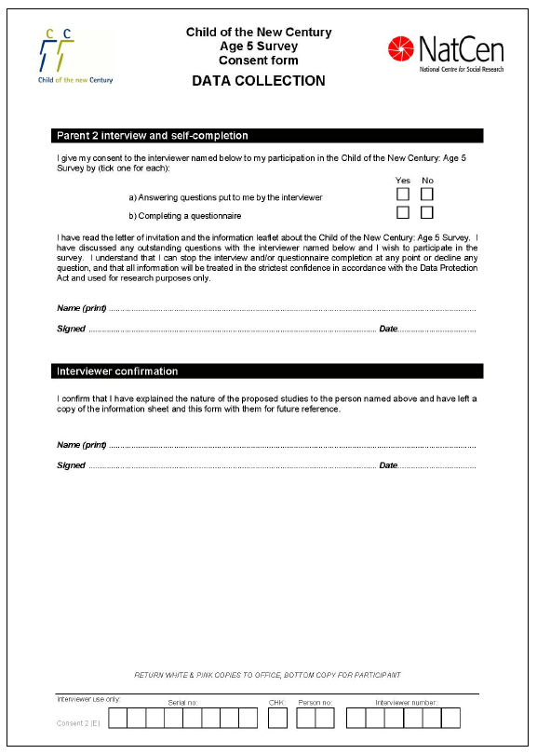
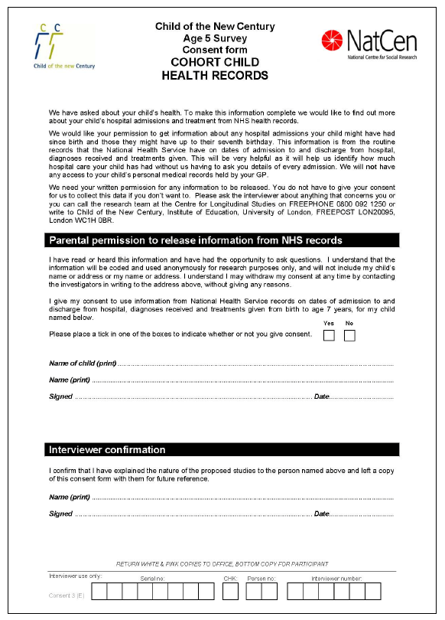
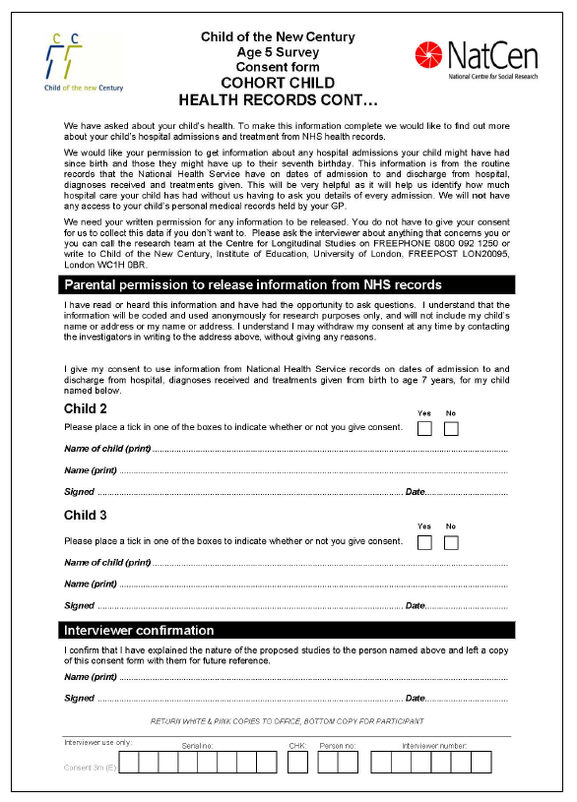
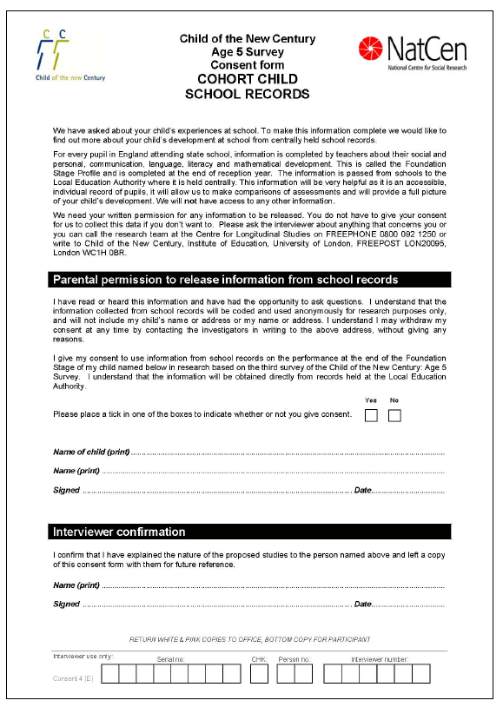
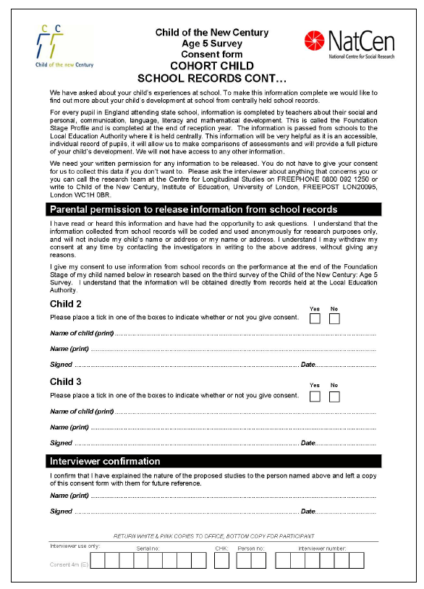
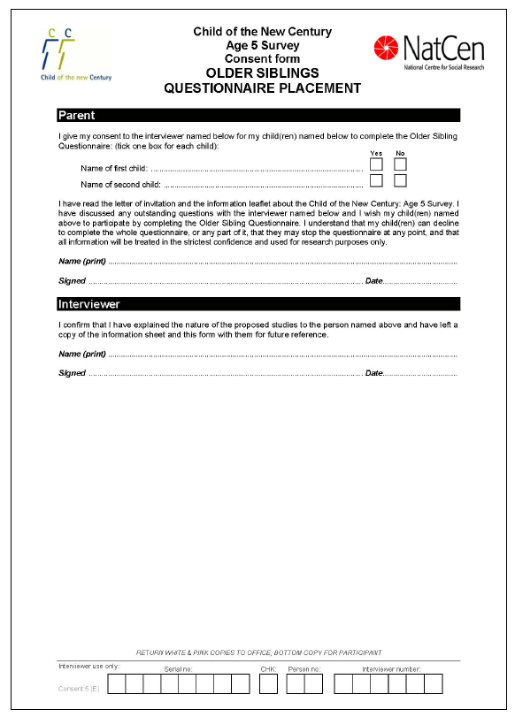
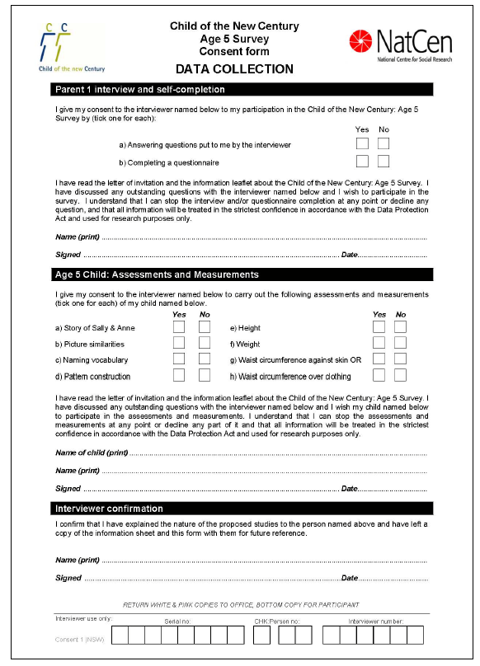
Northern Ireland, Scotland and Wales
(In Northern Ireland the NatCen logo was replaced by the NISRA logo)
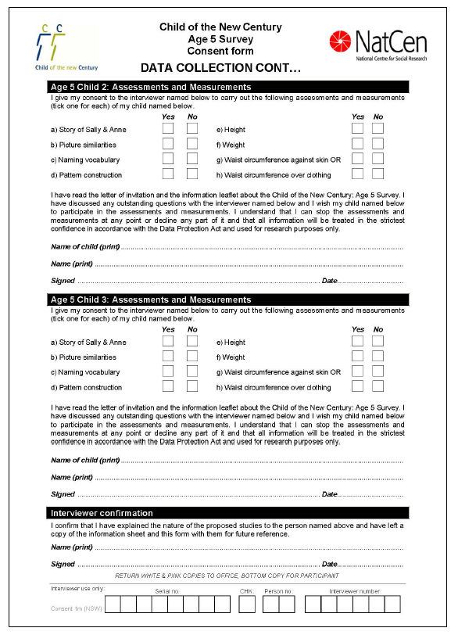
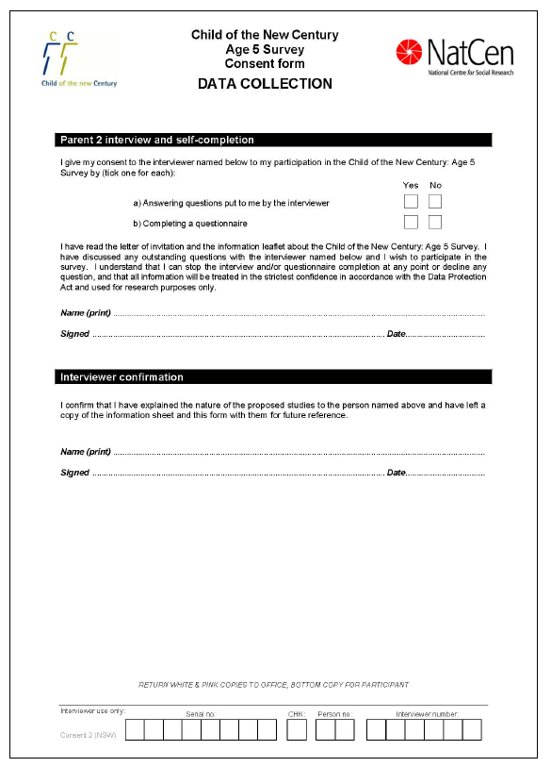
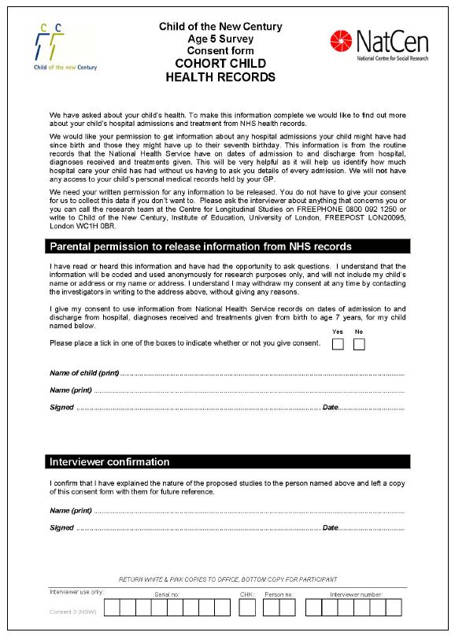
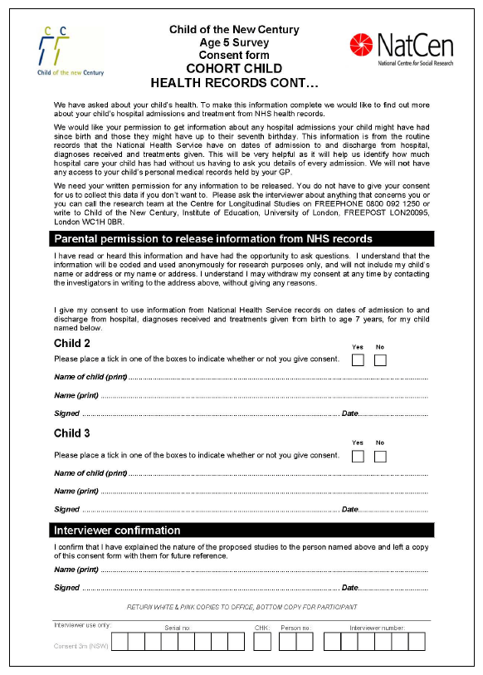
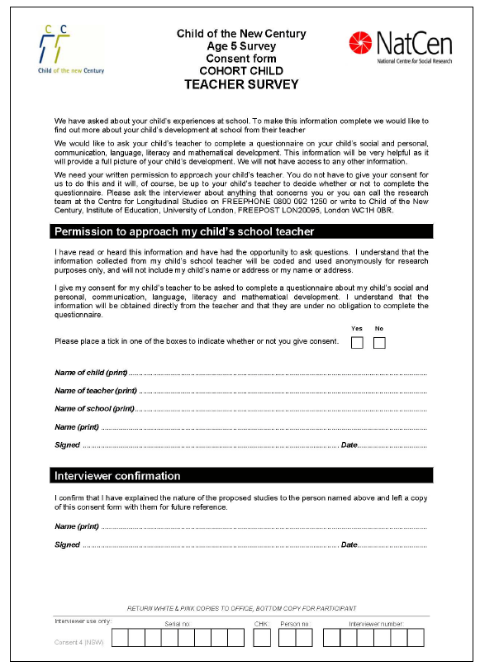
MCS4
See MCS4 Technical Report on Fieldwork - http://www.cls.ioe.ac.uk/shared/get-file.ashx?id=844&itemtype=document and http://www.cls.ioe.ac.uk/shared/get-file.ashx?id=912&itemtype=document

Pre-notification letter: Productive England Wales Scotland

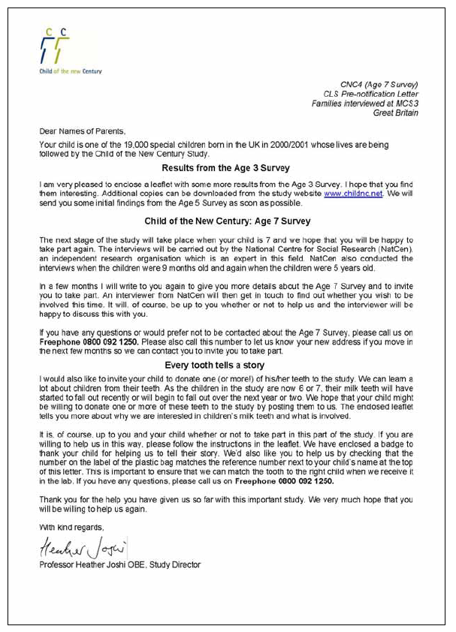
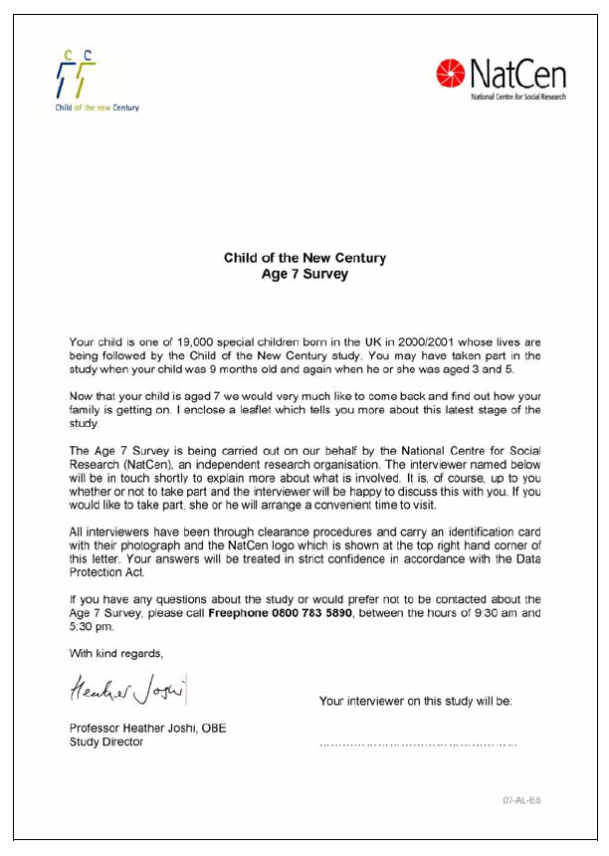
Advance letter: England, Scotland
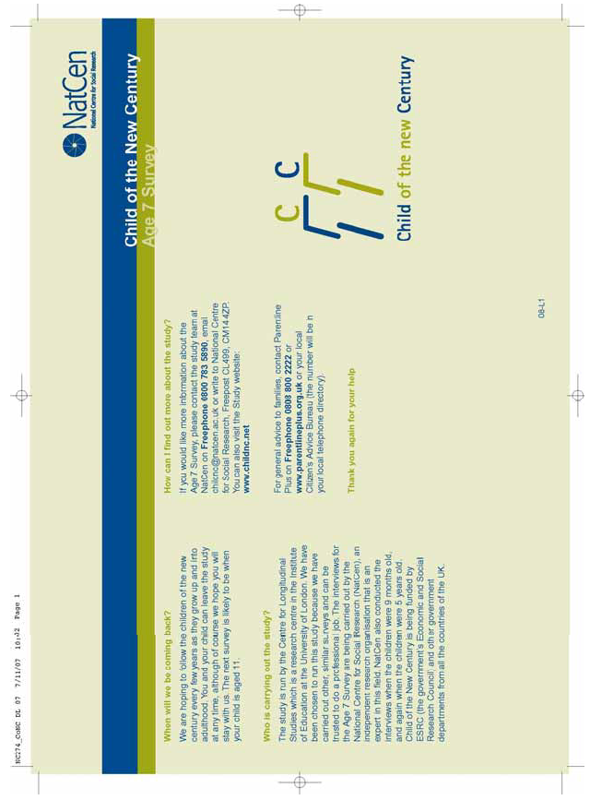
Leaflet sent with advance letter
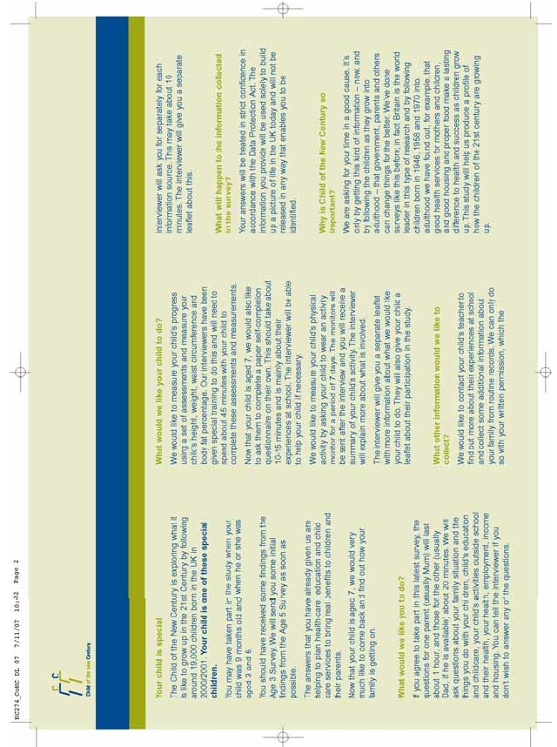
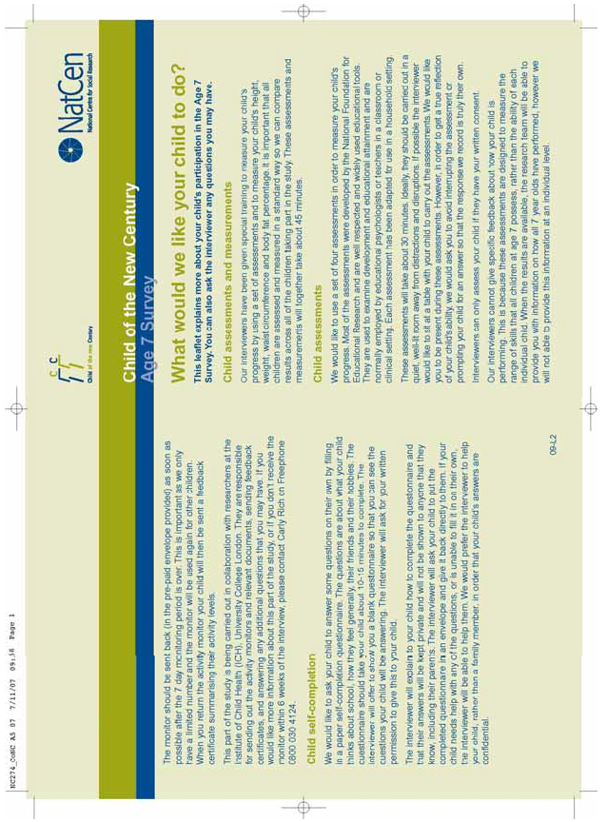
Second leaflet
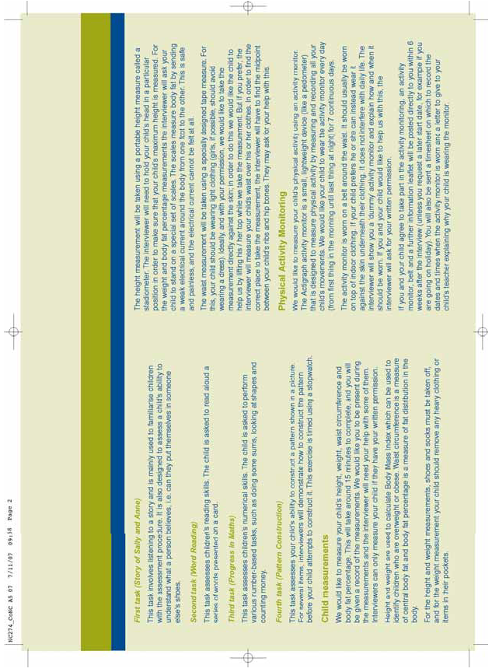
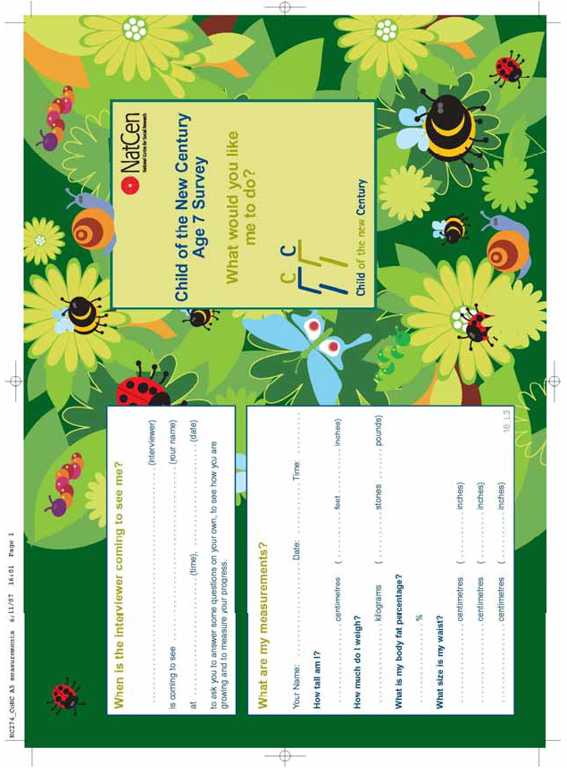
Child leaflet
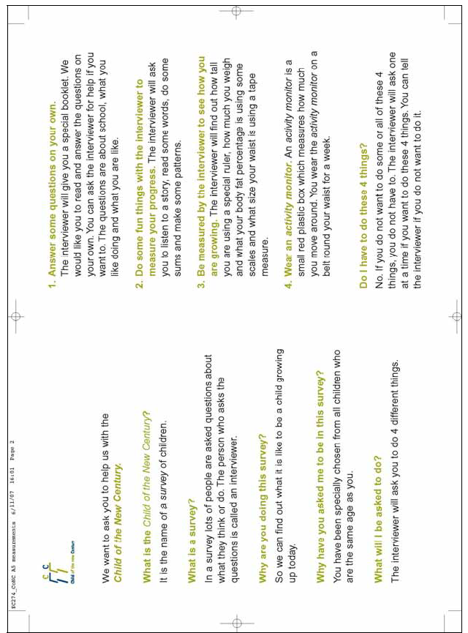
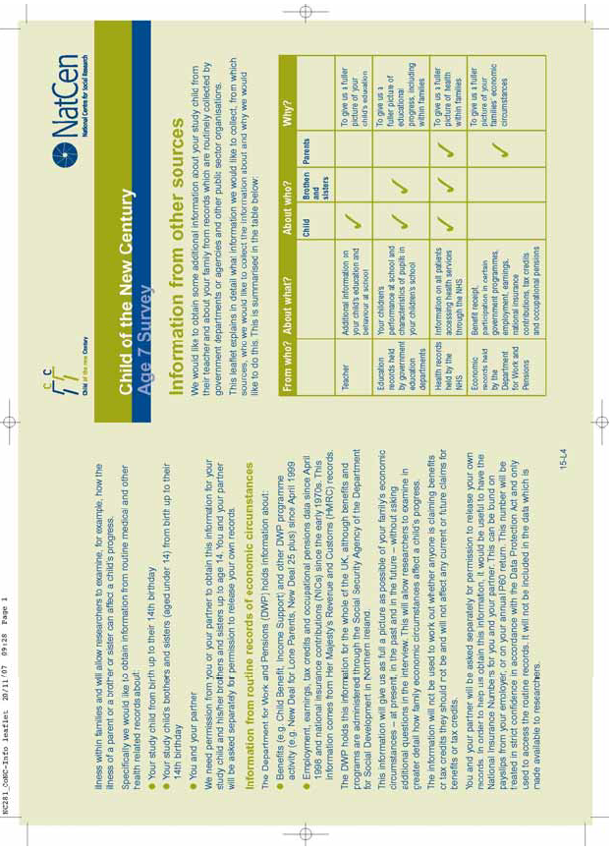
Information from other sources leaflet
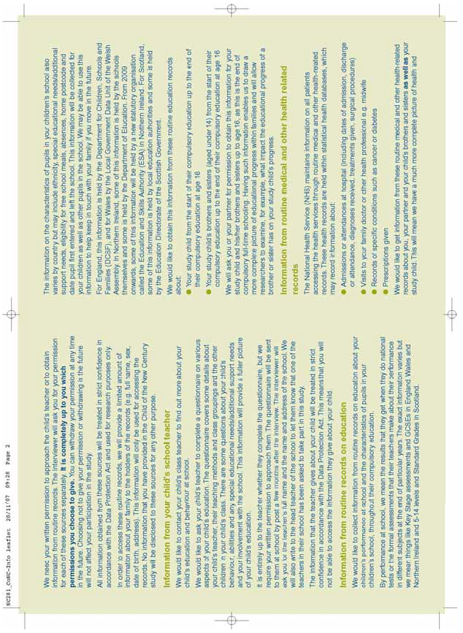

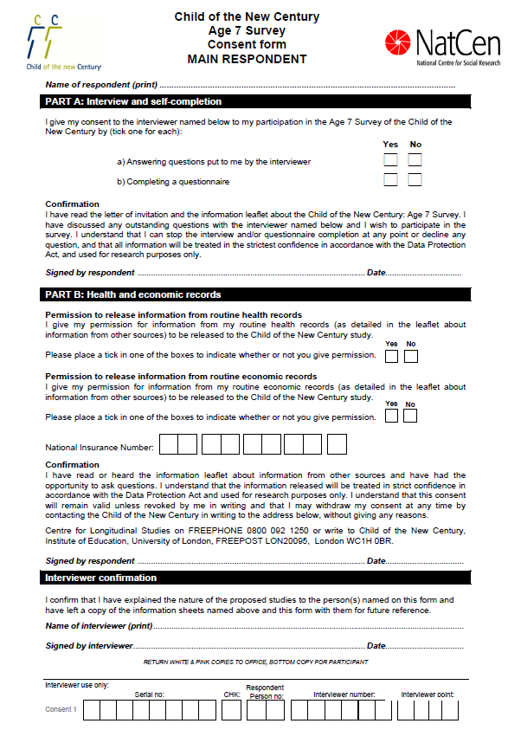
Consent forms
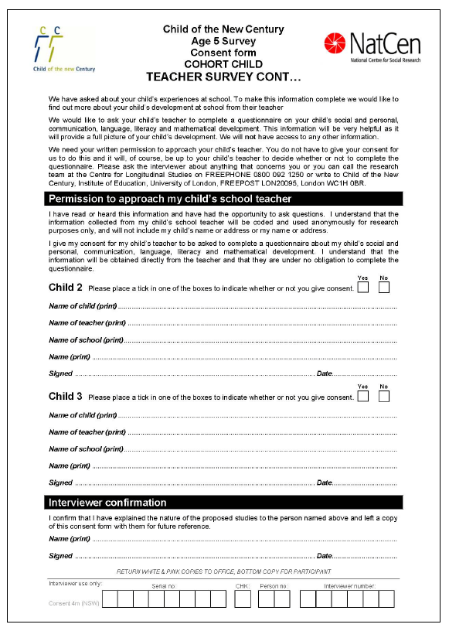

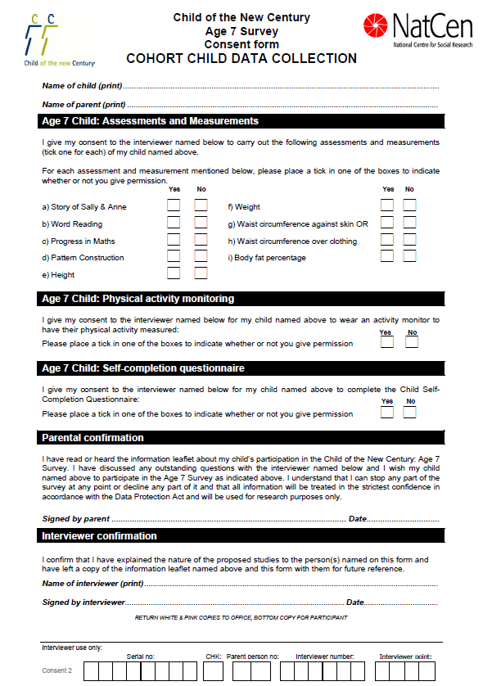
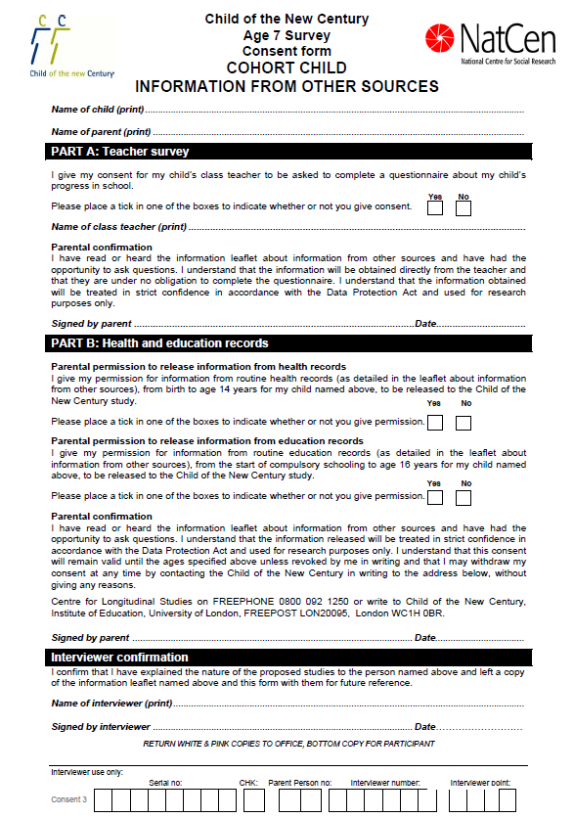
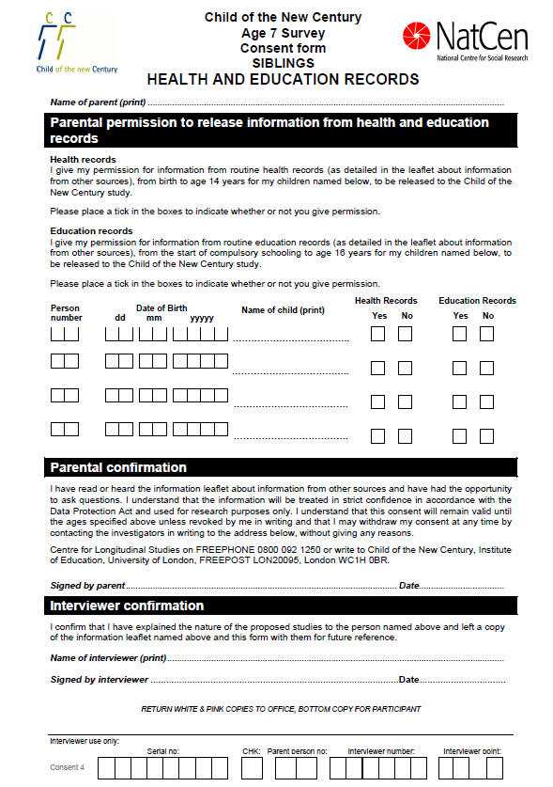
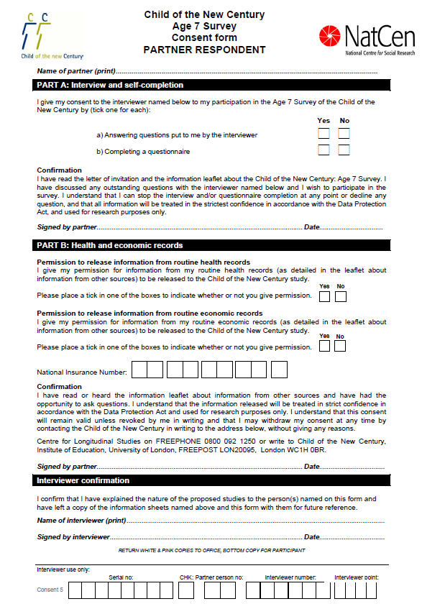

MCS5

Pre-notification mailing
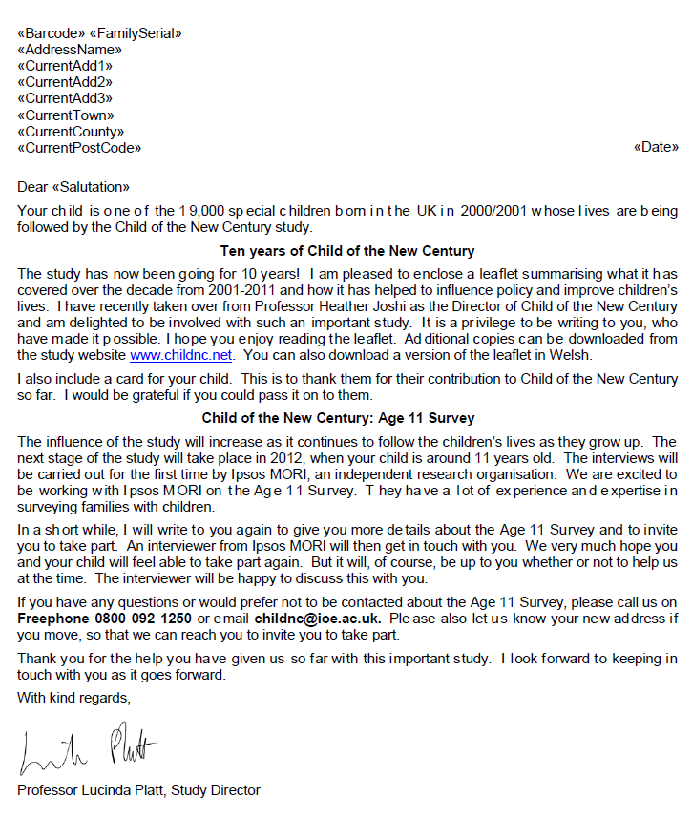
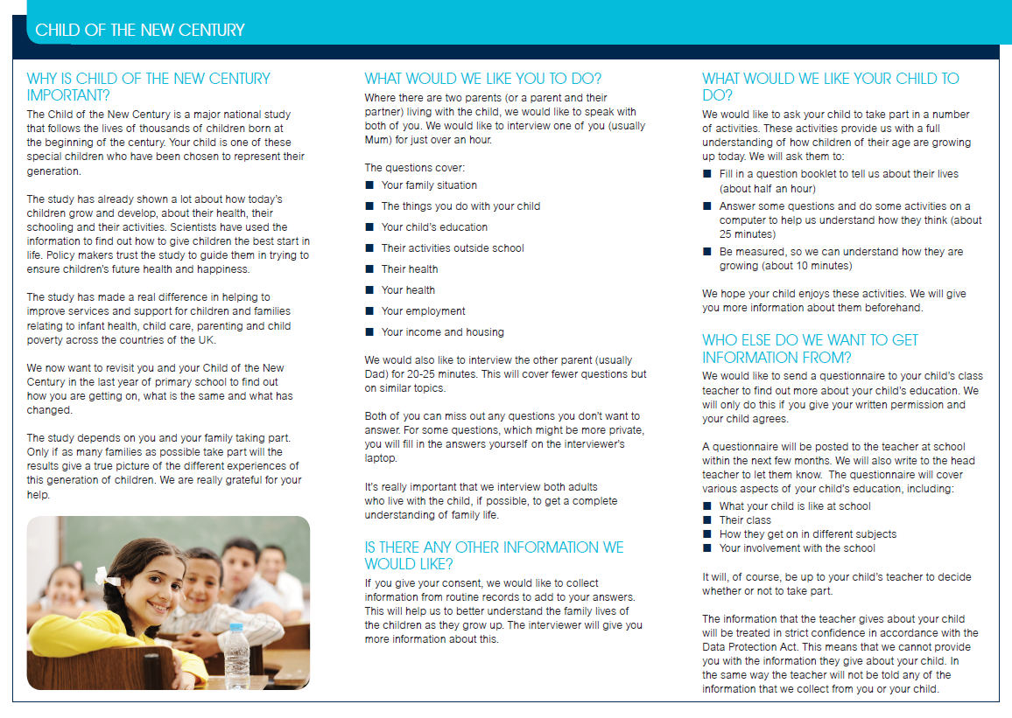
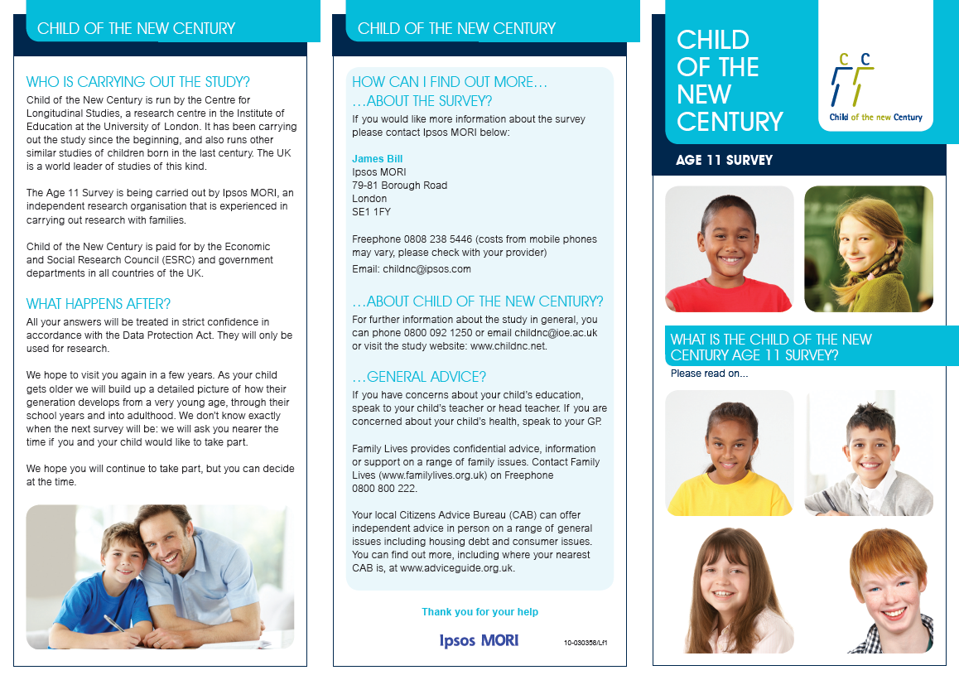
Advance leaflet for parents (England and Wales)

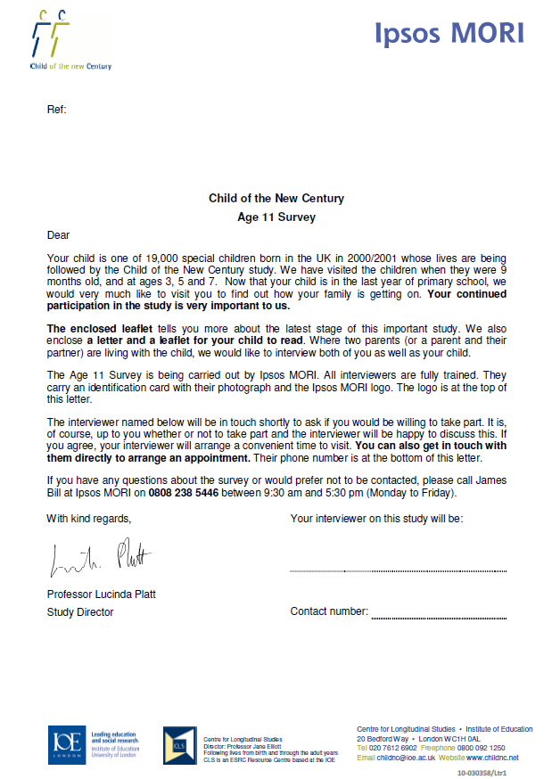
Advance letter
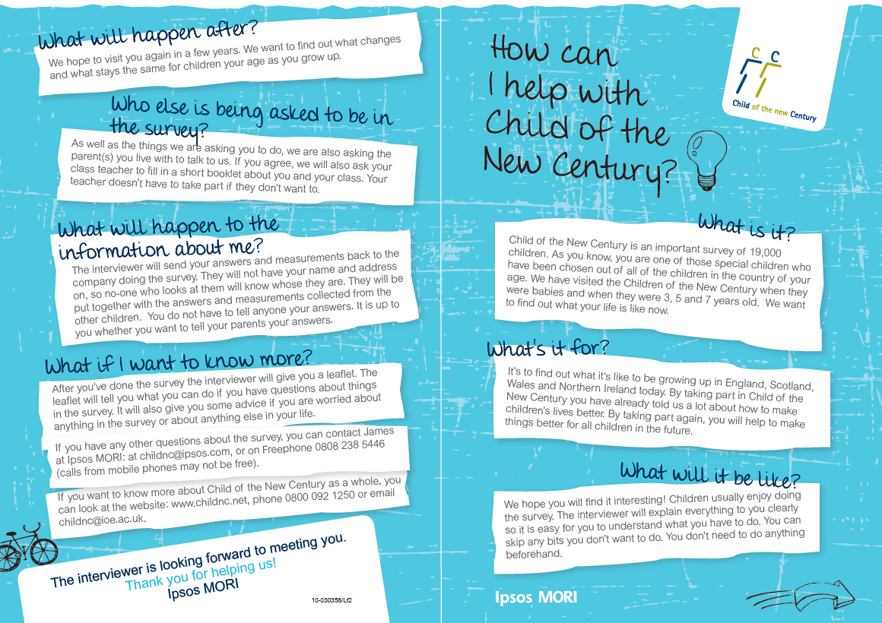
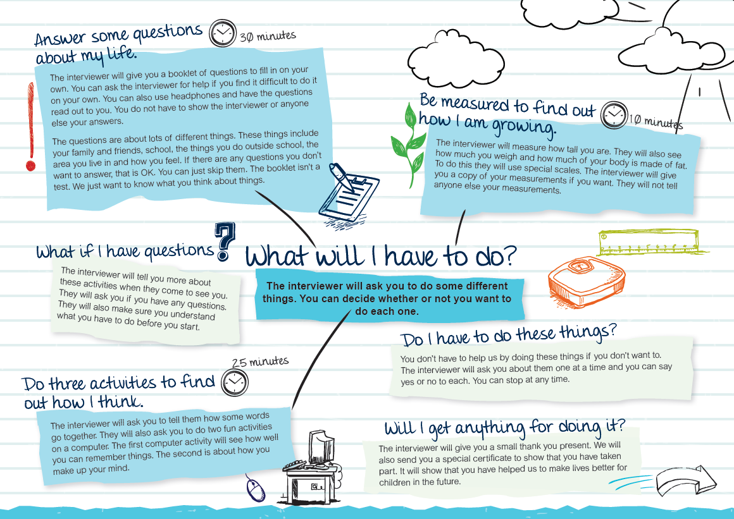
Advane leaflet for child (England and Wales)
Advance letter for child

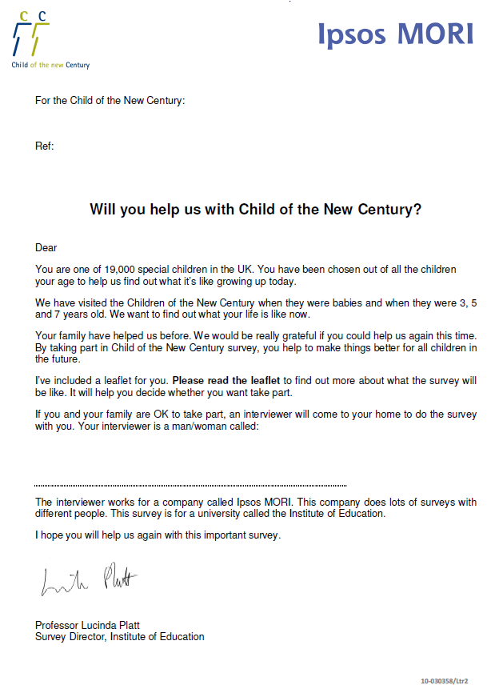
Child elements leaflet

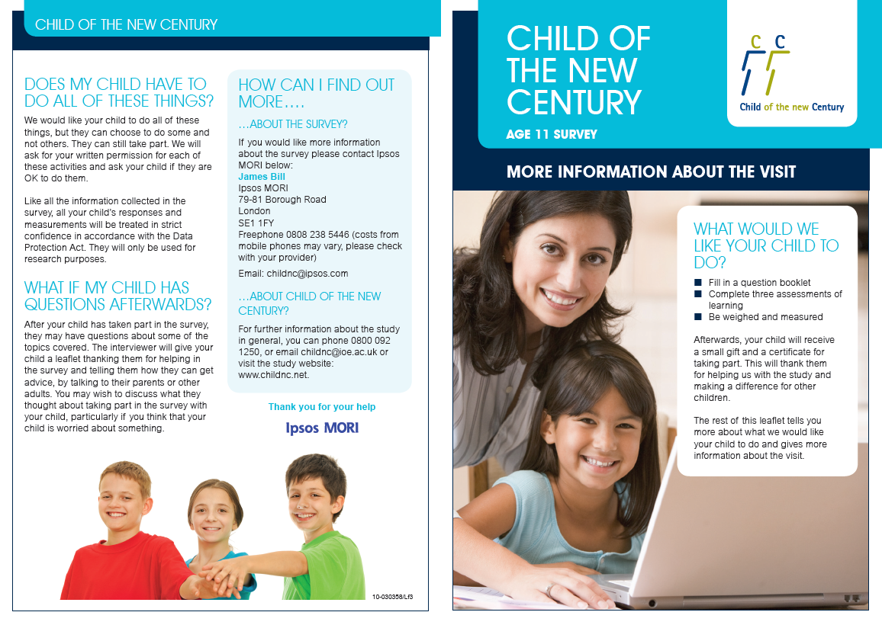

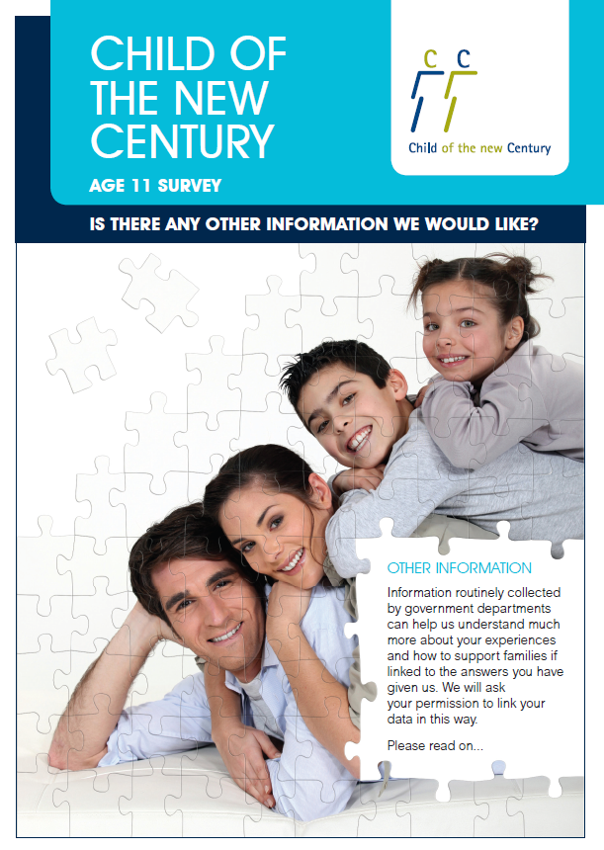
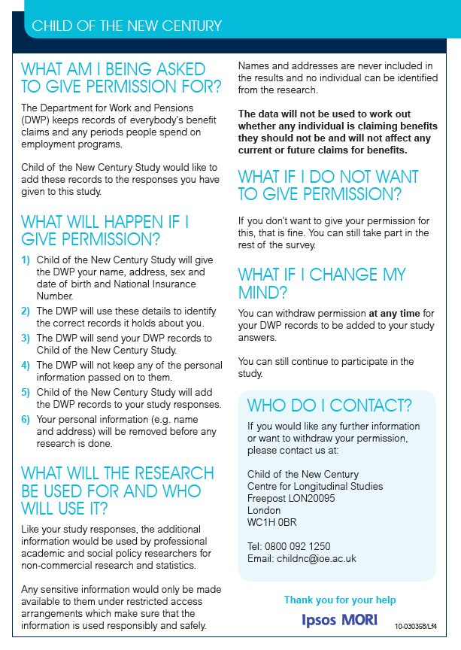

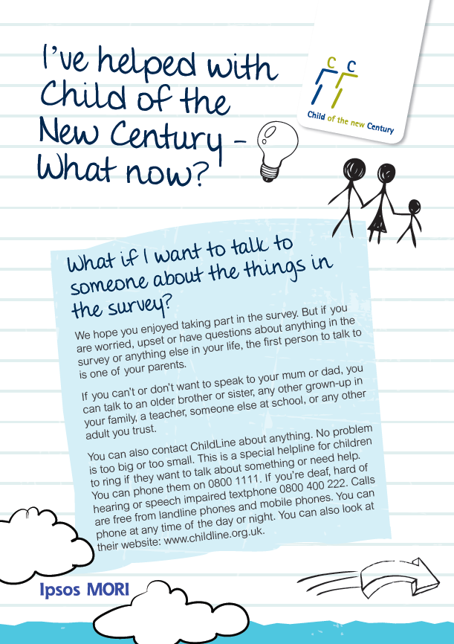

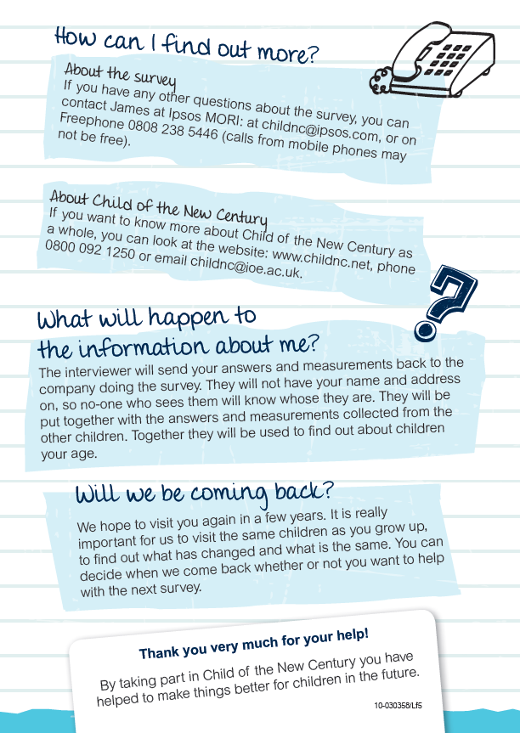

Partner letter

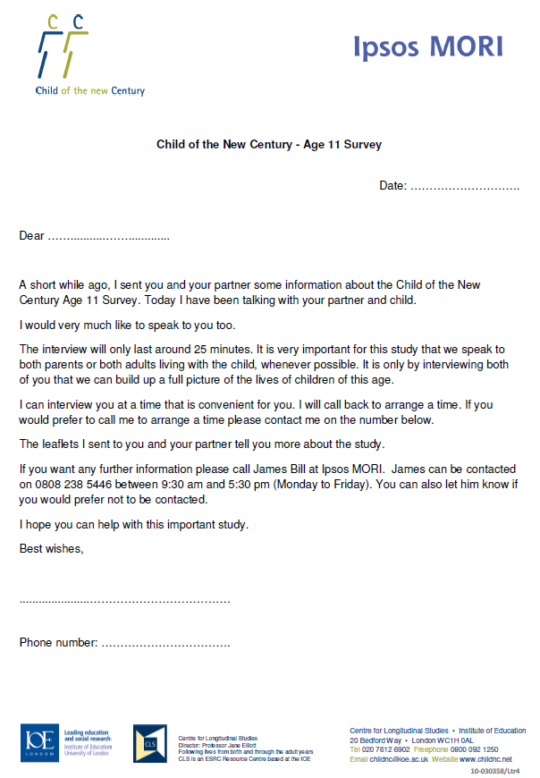

Consent form (Child) – England and Wales
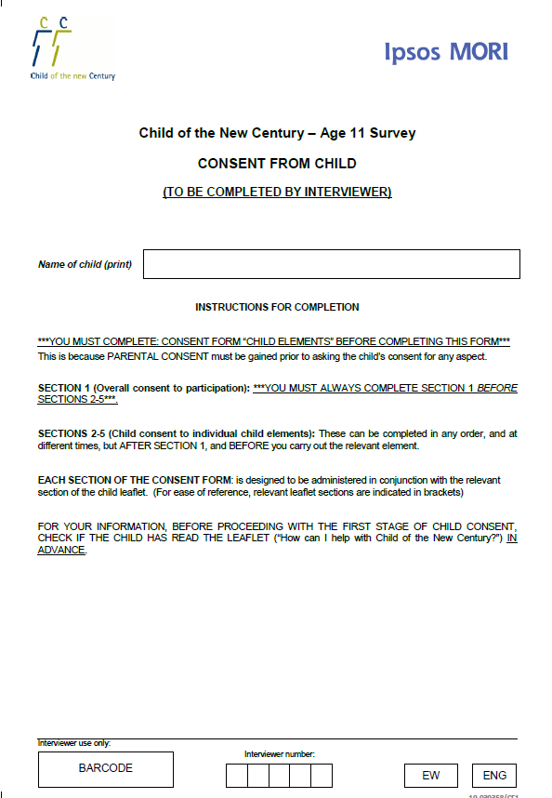
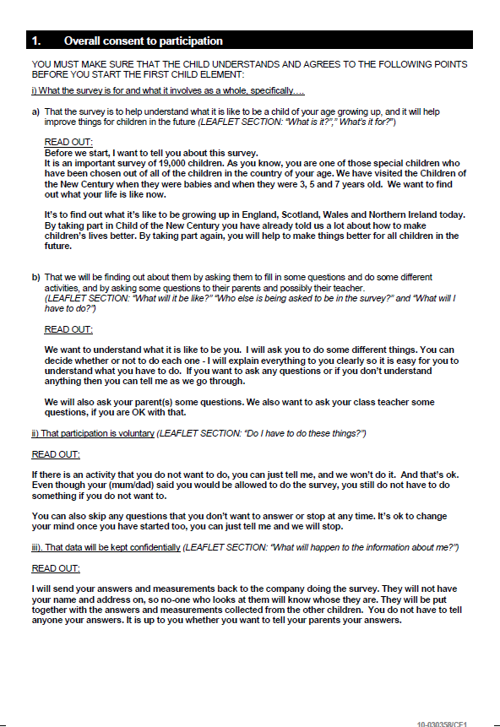
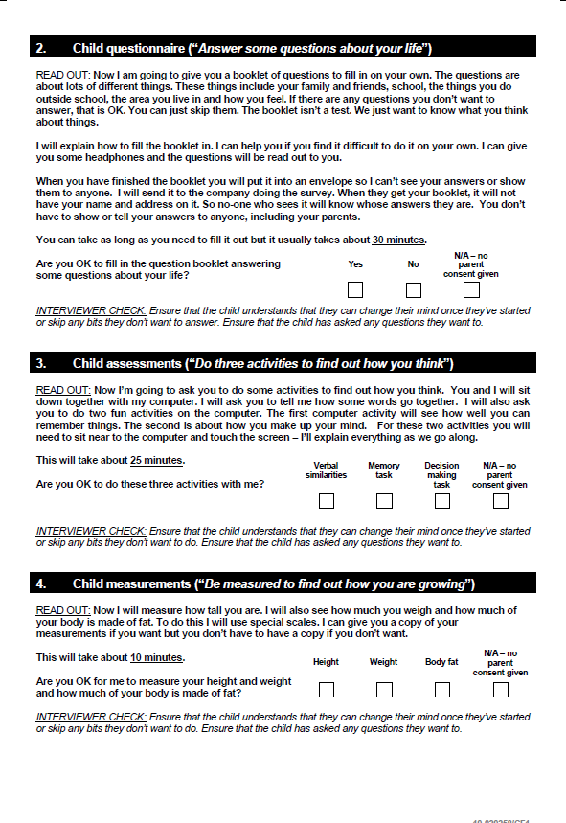

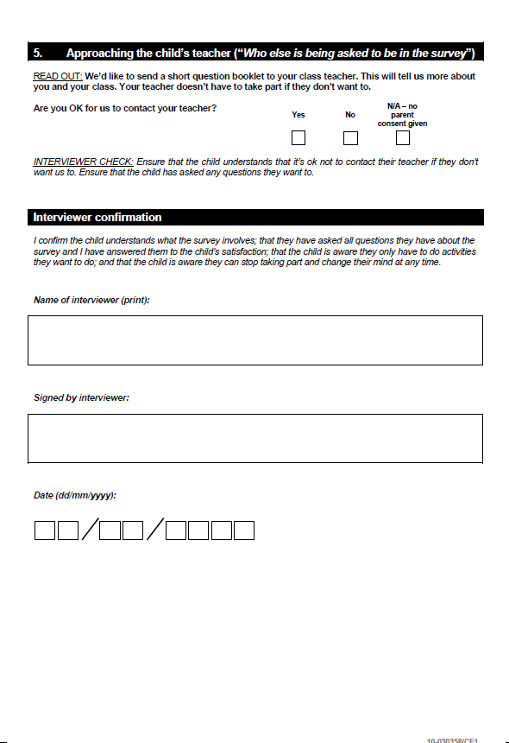
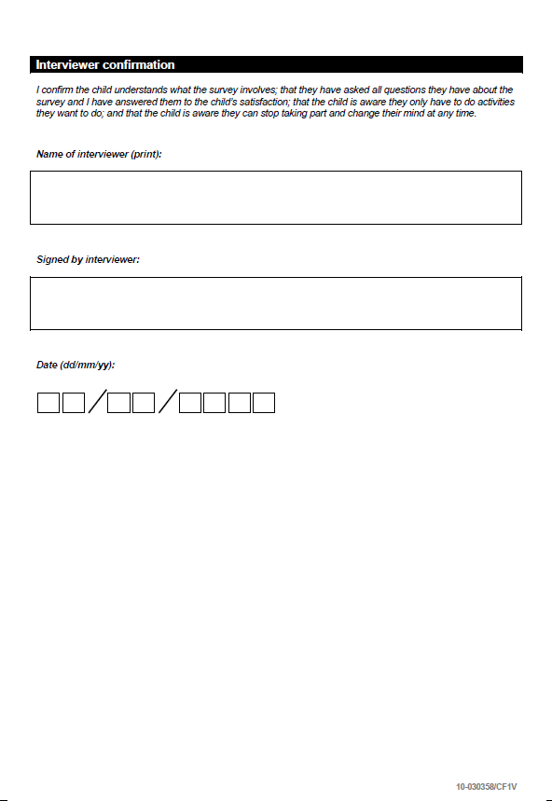

Consent form (Child elements) – England and Wales

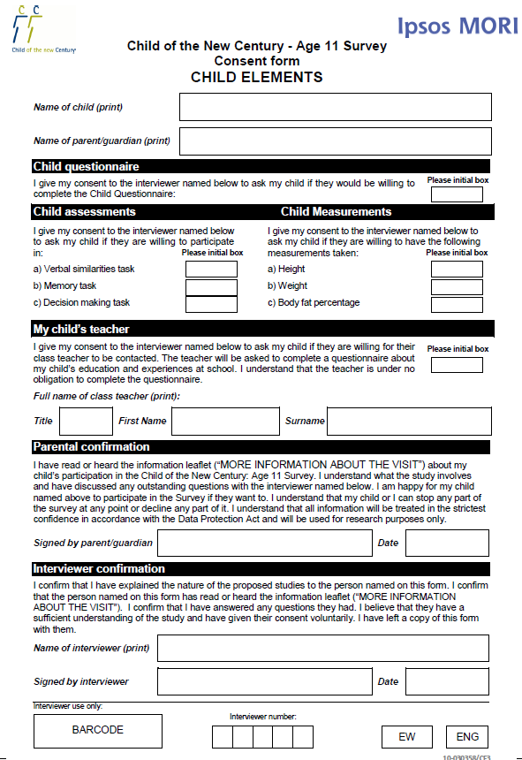
Consent form (Main parent)

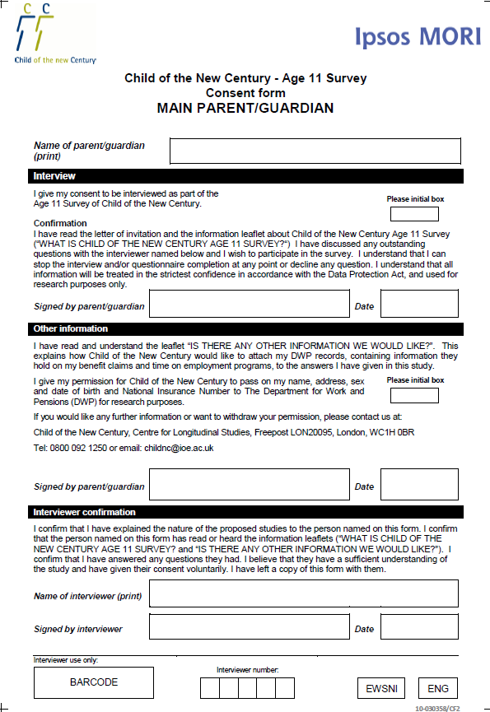

Consent form (Partner)

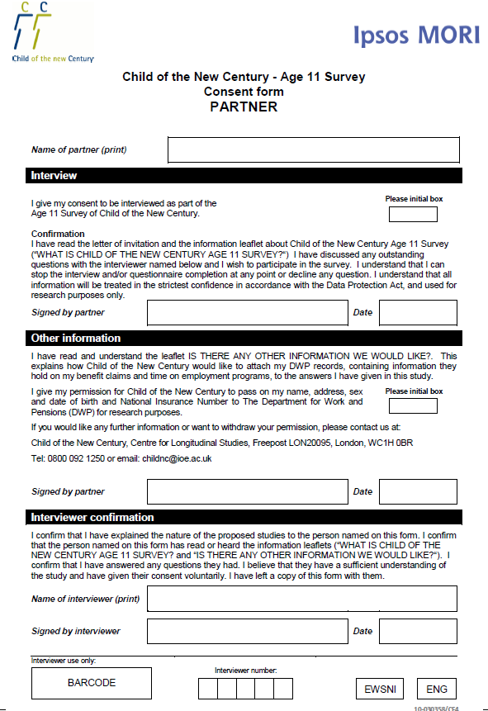

Letter from parent to teacher

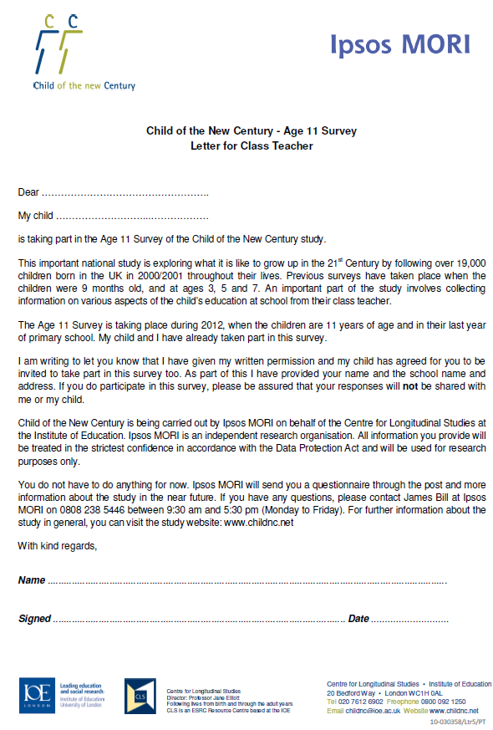

For more details see the NHS National Research Ethics Service website: http://www.nres.npsa.nhs.uk/

